

Palestine Technical University – Kadoorie College of Engineering and Technology Department of Computer Systems Engineering

Course name:

Software Engineering

Project title:

**DEVELOPING A CENTRALIZED COURSE PORTAL FOR EDUCATIONAL CENTERS IN PALESTINE**

By:

Abrar Arman – 202110760 | 4 Mayar Qasarwa – 202110541 | 3

Maysam Rashed - 202110544 | 3 Shahd Qalalwa – 202110631 | 4 Azza Eid – 202110543 | 2

Supervisor:

Dr. Osama Hamed

Tulkarm, Palestine Spring Semester 2023-2024

# Abstract

For more than four years, through Corona and what our country is witnessing due to the occupation, the educational process in Palestine has been suffering from great challenges, and despite the many attempts to advance the educational process, it is not far from what school students are suffering from, especially those of young ages. From another point of view, many of us, as university students, want to join educational courses to develop ourselves in many fields. The idea of ​​our project is to create a website that includes educational centers in the cities of Palestine so that it is easy to access these centers from one place and learn about the courses offered. we propose “Nebras” which is a website introduces an online educational platform designed to mitigate the impact of these disruptions. Our website empowers students, educational institutions, and learners by promoting accessibility, transparency, and efficiency. By leveraging technology, we aim to enhance the educational journey despite existing challenges. “Nebras” aim to facilitate the discovery and reservation of educational sessions, providing a centralized repository of information on educational centers. Our methodology employs a user-centric approach, emphasizing ease of access and communication. We have developed a system that allows students to reserve sessions based on their preferences, gather detailed information about educational centers, and utilize an intuitive search and booking process. The platform also establishes direct communication channels between students and centers. The main result of this initiative is an accessible, efficient, and responsive educational environment that adapts to the needs of students and educators alike. The conclusion drawn from the project is that technology can significantly bridge the educational gaps caused by unforeseen circumstances, ensuring continuity in learning and academic growth.

# 

# Abstract

منذ أكثر من أربعة سنوات مرورًا بكورونا ووصولًا إلى ما تشهده بلادنا من قبل الاحتلال فأن العملية التعليمية في فلسطين تعاني من تحديات كبيرة وعلى الرَّغم من المحاولات العديدة للنهوض بالعملية التعليمية إلا أنَّه ليس ببعيدٍ عن أحد ما يعانيه طلبة المدراس وخاصة ذَوي الأعمار الصّغيرة. فكانت فكرة مشروعنا هي إنشاء موقع إلكتروني يحتوي علي جميع المراكز في كل المدن الفلسطينية ما يسهل عملية الوصول لهذه المراكز من مكان واحد، ومعرفة الدورات التي تقدمها هذه المراكز. لذلك طرحنا في مشروعنا "نبراس" وهو موقع إلكتروني يقدم منصة تعليمية عبر الإنترنت تسعى للتخفيف من تأثير هذه الأزمات. يعمل موقعنا على تمكين الطُّلاب والمؤسسات التَّعليمية والمُتعلمين عن طريق تَعزيز الوصوليَّة والشَّفافية والكفاءة. ومن خلال الاستفادة من التكنولوجيا، نسعى إلى تعزيز رحلة التعليم على الرغم من التحديات القائمة. نهدف في "نبراس" إلى تسهيل اكتشاف وحجز الجلسات التعليمية، وتوفير مرجع مركزيِّ للمعلومات عن المراكز التعليمية. كما نستخدم منهجًا يركِّز على النهوض بتجربة المستخدم. حيث طورنا نظامًا يسمح للطلاب بحجز الجلسات بناءً على تفضيلاتهم، وجمع معلومات مُفصَّلة عن المراكز التعليمية، واستخدام عملية بحث وحجز سريعة. كما تقدم المنصَّة قنوات اتصال مباشرة بين الطلاب والمراكز. والنتيجة الرئيسية لهذه المبادرة هي بيئة تعليمية يسهل الوصول إليها، فعالة وسريعة الاستجابة، كما وتتكيَّف مع احتياجات الطُّلاب والمعلمين على حد سواء. وخلصنا في هذا المشروع إلى أن التِكنولوجيا يُمكن أن تَسد بشكل كبير الفجوات التعليمية المتعلقة بالأزمات، مما يضمن الاستمرارية في التَّعلم والنُّمو الأكاديمي.

# Table of contents

Abstract II  
 Abstract III

Table of contents IV

List of Figures VI

Chapter 1:Introduction 1

* 1. General Background 1
  2. Problem Statement 1
  3. General Objective 2
  4. Objectives 2
  5. Scope Of Work 3

Chapter 2: System Analysis& Requirements 4

2-1 Functional Requirements ………………………4

2-1-1 Admin ………………………4

2-1-2 User ………………………5

2-1-3 Teacher ………………………8

2-2 Non-Functional Requirements ……………………………..………………………9

Chapter 3:System Design 10

3-1 MVC Model 10

3-1-1 Overview 10

3-1-2 MVC Diagram 11

3-2 State Machine Diagrams 12

3-2-1User Interface 12

3-2-2 Admin Interface 13

3-2-3Teacher Interface 13

3-3Entity Relationship Data Model…….. ...………..14

3-3-1Entities 14

3-3-1Entities Description 14

3-3-3Relationships 15

3-3-4 Entity Relationship Model for Educational Center 16

3-3-4 Entity Relationship Diagram 17

Chapter 4: System Model 18

4-1  Use Case Diagrams 18

4-1-1 User 18

4-1-2 Admin 19

4-1-3 Teacher 20

4-2 Use Case Descriptions 21

4-3 Sequence Diagrams 23

4-4 Activity Diagrams 29

4-5 Class Diagram 32

Chapter 5: Interface Design 33

5-1 Home Page Design 33

5-2 User Interface 34

5-3 Admin Interface 39

5-4 Teacher Interface 42

References 44

Appendix 45

# List of Figures

Figure 3-1: MVC Diagram………………………………………………………………………………………....16

Figure3-2: State Diagram for User Interface……………………………………………..……….……..17

Figure3-3: State Diagram for Admin Interface……………………………………………………….…18

Figure 3-4: State Diagram for Teacher Interface………………………………………………..……..18

Figure 3-5: Entity Relationship Diagram…………………………………………………………..……….22

Figure 4-1: Use Case Diagram for User……………………………………………………………..………23

Figure 4-2: Use Case Diagram for Admin……………………………………………………….…………24

Figure 4-3: Use Case Diagram for Teacher…………………………………………………….…….……25

Figure 4-4: Sequence Diagram for Login& registration………………………………….…….…..28

Figure 4-5: Sequence Diagram for Center control……………………………………………..…….29

Figure 4-6: Sequence Diagram for course control……………………………………..……..…….30

Figure4-7: Sequence Diagram for add & Edit Material………………………………...…..………31

Figure 4-8: Sequence Diagram for view Course Feedback………………..………….…..……..32

Figure 4-9: Activity diagram for Feedback ……………………………………..……………………......33

Figure 4-10: Activity diagram for Generating Report...............................................................35

Figure 4-11: Activity diagram for Editing Account…............................................................... 36

Figure 4-12: Class Diagram………………………………………..……………………..…………..…….…….37

## Chapter 1: Introduction

### General Background

Over the past four years, students in Palestine have faced significant challenges in their educational journey. These challenges began with the outbreak of the COVID pandemic in 2020, which disrupted and slowed down the educational process. With the aftermath of the COVID-19 pandemic, Palestine witnessed a series of negative events that adversely affected education, including the 2021 war on Gaza, the teachers' strike, and the 2023 war. Students have been affected during this period by a reduction in the quality of education and a decline in their academic performance, as testified by parents and teachers.

Additionally, these challenges have not been limited to school students alone, but have extended to university students and learners in training centers and educational institutions. Everyone has been affected by the disruption of classes and the discontinuation of the educational process, leading to a decline in academic performance and an increase in the educational gap.

### Problem Statement

The impact of these adverse conditions on the educational process in Palestine is alarming, leading to a decline in students' academic levels and a deterioration in the quality of education. Therefore, it is imperative to search for technological educational solutions that contribute to enhancing the quality of education and motivating students to learn and grow academically despite the existing challenges.

### General Objective

Our goal through our website is to streamline the process of finding suitable educational courses, whether for school students or others. This will be achieved by establishing an organized platform that facilitates searches based on educational materials, geographical location, or the method of course delivery (in-person or online). Simultaneously, it aims to simplify the organization of educational courses within educational institutions, while at the same time enabling them to advertise their services effectively.

### Objectives

* + 1. **Educational Session Reservation**: Create a system where students can reserve educational sessions\ Allow them to choose sessions based on their preferences and availability\ Implement booking features to secure their spots.
    2. **Educational Center Information**: Gather comprehensive details about educational centers\Include information such as courses offered, schedules, and physical locations\Ensure accurate and up-to-date data.
    3. **Student-Friendly Search and Booking**: Design an intuitive search function for students\ Enable easy exploration of available sessions\ Streamline the booking process.
    4. **Seamless Communication**: Build channels for communication between students and centers\ Provide support for inquiries, updates, and assistance\ Foster a collaborative environment.

### Scope of Work

On this system we will focus on developing an online educational platform that aims to facilitate the reservation of educational sessions and provide information about educational centers in **major cities in Palestine**. The platform will include features such as searching for educational centers, viewing available sessions, and booking sessions online. Additionally, the platform will enable communication between students and educational centers, ensuring a seamless experience for both parties.

## Chapter 2: System Analysis& Requirements

2-1 Functional Requirement

2-1-1 Admin:

**1- The Admin shall be able to add a course.**

**1.1** To add a course the admin shall enter course name, description and appointment to this course.

1.2 The system shall ensure that this admin has the authority to add a course to this particular center.

**1.3** After adding the course, a message shall appear to the admin stating that the course has been added successfully.

**1.4** The system shall verify that this course doesn’t exit previously, If it exists, the process of adding the course will be rejected and a message will appear to the admin.

**1.5** The system shall allow the admin to add any number of courses he wants.

**The Admin shall be able to delete a course. 2**-

**2.1** Before deleting the course, a warning message shall appear to the admin, so that the deletion process does not occur until he/she

click to confirmation message.

**2.2** After the deletion process occurs, it shall appear immediately to all users.

**3- The Admin shall be able to edit a course.**

**3.1** Before editing the course, a warning message shall appear to the admin.

**3.2** After the course edit it shall appear immediately to all users.

**The Admin shall be able to edit his account. 4**-

**4.1** Before the admin edit his account he will be asked to enter the original password and a code will be sent to him on his email that shall be entered then he can edit his account.

**5- The Admin shall able to generate a report.**

**5.1** The report must include a summary of all the courses offered, the number of students in each course, and their dates

**6-The Admin shall be able to keep track for each course offer.**

**6.1** The admin shall be able to know the number of students in each course, and if a student registers, a notification will be sent to the admin.

**The Admin shall be able to offer a job. 7-**

**7.1** If the center needs a teacher, for example, the admin will submit this request on the home page of our website.

**7.2** A notification shall be sent to all people who have an account on our website.

**8- The Admin shall be able to see feedback about the center and about each course.**

**9- The Admin shall be able to register a new Teacher.**

**9.1** Admin fills out the form for registering new Teacher with the

required data **.**

**10- The Admin shall be able to revoke permission from Teacher.**

2-1-2 User:

**1-The user shall be able to create account.**

have **1.1** To access all the features offered by the site the user shall account to achieve this, a screen will appear asking the user to information.

**1.2** The process of create account can be in 2 ways. In the first way, the user enters both his email and password, and the other way by using Gmail or Facebook .

**1.3** If the user forgot his password, he will get the password through a message on his email after click “forget my password".

**see every center displayed on the website. to 2- The user shall be able**

**2.1**After the user creates his account, he will be taken to the main page of

our website, which includes several centers.

**2.2** If the user is searching for a center in a specific city, he can choose the city and then see the centers in the city he chose.

**2.3** If the user wants to see additional information about the center in terms of the date of establishment, educational staff, etc. he shall click on the center he wants.

**3- The user shall be able to see the courses available in each center.**

**3.1** If the user is searching for a course and does not know the centers that offer it, our website will display all the available courses, and after clicking on the course he wants, he will be taken to a page containing all the centers that offer this course. If he is interested in a course offered in which a specific center is offered, he can click on the name of center only.

**3.2** After accessing the course he wants, he can click on it to see information about it dates, description and its completion period, etc.

**4- The user shall be able to register for the course he wants.**

**4.1**In order for the user to register, he shall enter some information also the course must be open.

**4.2** The user will not be able to see any materials within the course until he pays a certain amount according to the center’s system.

**4.3** After registering and fulfilling all conditions, the user will be able to access the displayed materials and can download them as needed.

**4.4** If any material is added, the user shall be notified.

**5- The user shall be able to pay through the website .**

**5.1** If the user wants to make the payment process, he will be taken page designated for making the payment after entering some information, and a warning message will be sent before carrying out the process.

**6- The user shall be able to edit his account.**

**6.1** Before the user edit his account he will be asked to enter the original password and a code will be sent to him on his email that shall be entered

then he can edit his account.

**7- The user shall be able to follow the centers he is interested in.**

**7.1** By clicking a button within each center, any user will be able to know if a course has been added in the center he is interested in.

**8- The user shall be able to provide feedback to the center.**

**8.1** The user shall be registered in at least one course to be able to provide feedback to the center.

**9- The user shall be able to download any material he wants.**

**9.1** The system shall be able recognize this user as having the authority to access the course materials.

**10- The user shall be able to apply a job.**

**10.1** Our website shall send notifications to all users, so if the user has the qualifications, he can apply for the job by filling out some information, and if he is accepted, a message will be sent to him.

**11- The user shall be able to see the location of each center.**

**11.1** In order for the user to be able to do this, he shall click on a dedicated button on the page, then choose the city in which the center is located. Then our page will describe how to reach the center in the shortest possible way.

2-1-3 Teacher:

**1- The user shall be able to login as a Teacher.**

**1.1** The system shall be to distinguish that this account belongs to a teacher, and this teacher also belongs to a specific center and cannot perform any operations except for the center affiliated with him.

**2-** **The Teacher shall be able add** **material.**

**2.1** The system shall be able to distinguish that this teacher has permission to add materials to this particular course.

**2.2** To add materials, some information shall be written, such as the name of this material, a description, etc.

**2.3** After adding the material , a message shall appear to the teacher stating that the material has been added successfully also a notification shall be sent to the admin that material has been added to a specific course .

**2.4** The teacher shall be able to add any number of materials in any type: pdf, word, video, etc.

**3-** **The Teacher shall be able delete material.**

**3.1** Before deleting a material, a warning message shall appear to the teachers

**3.2** After the deletion process occurs, it shall appear immediately to all users

**4- The Teacher shall be able edit** **material.**

**4.1** Before editing the material, a warning message shall appear to the teacher.

**4.2** After the material edit it shall appear immediately to all users.

**5- The Teacher shall be able to edit account.**

**5.1** Before the user edit his account he will be asked to enter the original password and a code will be sent to him on his email that shall be entered then he can edit his account.

**6- The teacher shall be able to contact with student**.

2-2 Non-Functional Requirements:

**1-Usability:** The system shall have a simple user interface (so any user can deal with our website easily without any help frames).

**2-Security:** The system shall contain login page and the user sign up to create account and login for the system and the password must be at least 9 characters.

**3-Portability:** The system shall be compatible with various devices, such as phones, tablets, etc.

**4-Availability**: The system shall be always available for access by users 24 hours for each day.

**5-Performance:** The system shall respond to user requests in a short time, and the user can perform many operations in a short time.

**6-Scalability**

The system shall be able to handle an increasing number of users, courses.

## Chapter 3: System Design

## 

3-1 MVC model design:

3-1-1 Overview:

The MVC (Model-View-Controller) model for a would involve the following components:

1. Model: This layer would handle the data logic and represent the structure of the database where all course information, user accounts, roles, permissions, and other data are stored. It would include:

* + Course data models with properties like name, description, and appointment.
  + User models with different roles (admin, user, teacher) and their respective permissions.
  + Authentication models to handle login credentials and password resets.

1. View: This layer would be responsible for the presentation logic, displaying the user interface where admins, users, and teachers interact with the system. It would include:
   * Interfaces for admins to add, delete, or edit courses, generate reports, and view feedback.
   * User interfaces for account creation, course browsing, registration, payment, and material downloads.
   * Teacher interfaces for adding, deleting, and editing course materials and managing their accounts.
2. Controller: This layer would manage the application logic, processing user input, and interacting with the Model to render the final output in the View. It would include:
   * Controllers to handle requests for adding, deleting, and editing courses.
   * Controllers to manage user authentication, registration, and profile editing.
   * Controllers for teachers to manage course materials and communicate with students.

### 3-1-2 MVC Diagram:

### considering the functionalities required, the system include:

### A web server to handle HTTP requests.

### An application server where the MVC application runs.

### A database server to store and manage all the data.

### Authentication services for secure login and user management.

### 

### Figure 3-1

### 3-2 State Machine Diagram:

In this part, we delve into the use of state diagrams as a powerful tool for modeling system behavior. We will examine the different states that our system can occupy, the events that trigger transitions between these states, and the actions that occur as a result of these transitions.

### 3-2-1User Interface:

### 

## Figure 3-2

### 3-2-2 Admin Interface:

## Figure 3-3

## 3-2-3 Teacher Interface:

## 

## Figure 3-4

3-3 Entity Relationship Data Model:

3-3-1Entities:

## To make our database ER diagram simpler to understand, we have divided the entities into several functional groups:

* + - **User Management:** Student, UserAccount, Admin, Teachrer.
    - **Course Management**: Course, Center, CourseMaterials, CourseSchedule.
    - **User Preference:** CenterFotSchoolStudent, AcademicCenter.
    - **Scheduling:** CourseSchedule, ClassRoom.
    - **Notifications & Communications:** Notifications ,Phone.
    - **Financial Transactions:** Payment.
    - **Feedback:** Feedback.

### 3-3-2 Entities Description

**UserAccount:** Manages login credentials and user profiles. Attributes often include username, password, and user role.

**Admin:** Users with elevated privileges to manage the system. Attributes could include admin ID and access level.

**Teacher:** Instructors responsible for teaching courses. Attributes may include teacher ID, name, and subject expertise.

**Student:** Represents individuals enrolled in the academic center. Holds personal information, academic major, and enrollment status.

**Course:** Contains details of courses offered, including name, associated class rooms, and related materials like syllabus.

**CourseMaterials:** Educational content provided for courses.

**CourseSchedule:** Timetable details for courses- Manages when and where courses are held.

**CenterForSchoolStudent:** Specialized in strengthening courses for school students.

**AcademicCenter:** Specialized centers focused on academic excellence.

**Notifications:** Sends messages to users, such as reminders or alerts, and tracks whether they have been read.

**Phone:** Contact information for communication.

**Payment:** Handles financial transactions related to course enrollments, including payment amounts and methods.

**Feedback:** User-submitted evaluations and comments.

### 3-3-3 Relationships

* + - **Student** to **CourseSchedule**: student can be scheduled for many course sessions, and a course schedule can include many students.
    - **Student** to **Course**: A student can review multiple courses, and a course can have multiple reviews.
    - **Student** to **Course**: students can list multiple course they wish to take, and a courses can be in many students wish list.
    - **Payment** to **Student**: Each student has a payment record.
    - **Teacher** to **CourseSchedule**: A teacher can teach many course appointments, and a course can be taught by many teachers.
    - **UserAccount** to **Students/Admins**/**Teacher**: A user account is linked to one subclass which represented by disjoint specialization.
    - **Notifications** to **UserAccount**: A user account can receive multiple notifications.
    - **Feedback** to **UserAccount**: A user can submit multiple feedback entries.
    - **Phone** to **UserAccount**: A user can have multiple phone numbers.
    - **Center** to **Course**: A center offers multiple courses.
    - **Center** to **UserAccount:** multiple users can visit multiple centers.
    - **Center** to **AcademicCenter\ CenterForSchoolStudent**: A center is linked to one subclass which represented by disjoint specialization.
    - **CourseSchedule** to **Courses**: Each course has multiple schedules.
    - **CourseSchedule** to **ClassRoom**: A classroom can be used for many course schedules.
    - **CourseMaterials** to **Courses**: A course can have multiple materials.

### 

### 3-3-4 Entity Relationship Model for Educational Center

Our Entity Relationship model serves as a foundation for building a robust and efficient database system that supports educational processes, user interactions, and administrative tasks. By understanding these entities and their relationships, we can create a well-structured and reliable database to meet our system’s requirements (shown in Figure **3-3-1** below).

3-3-5 Entity Relationship Diagram:

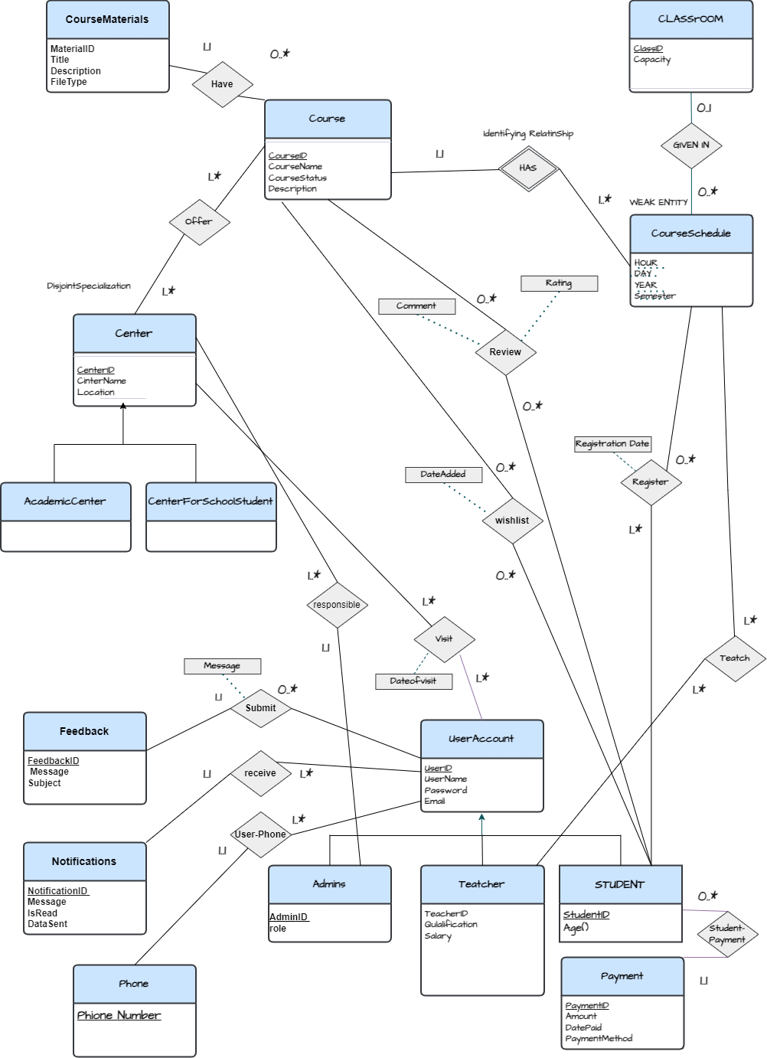

**Figure 3-5**

## Chapter 4: System Model

4-1 Use Case Diagrams

4-1-1 User

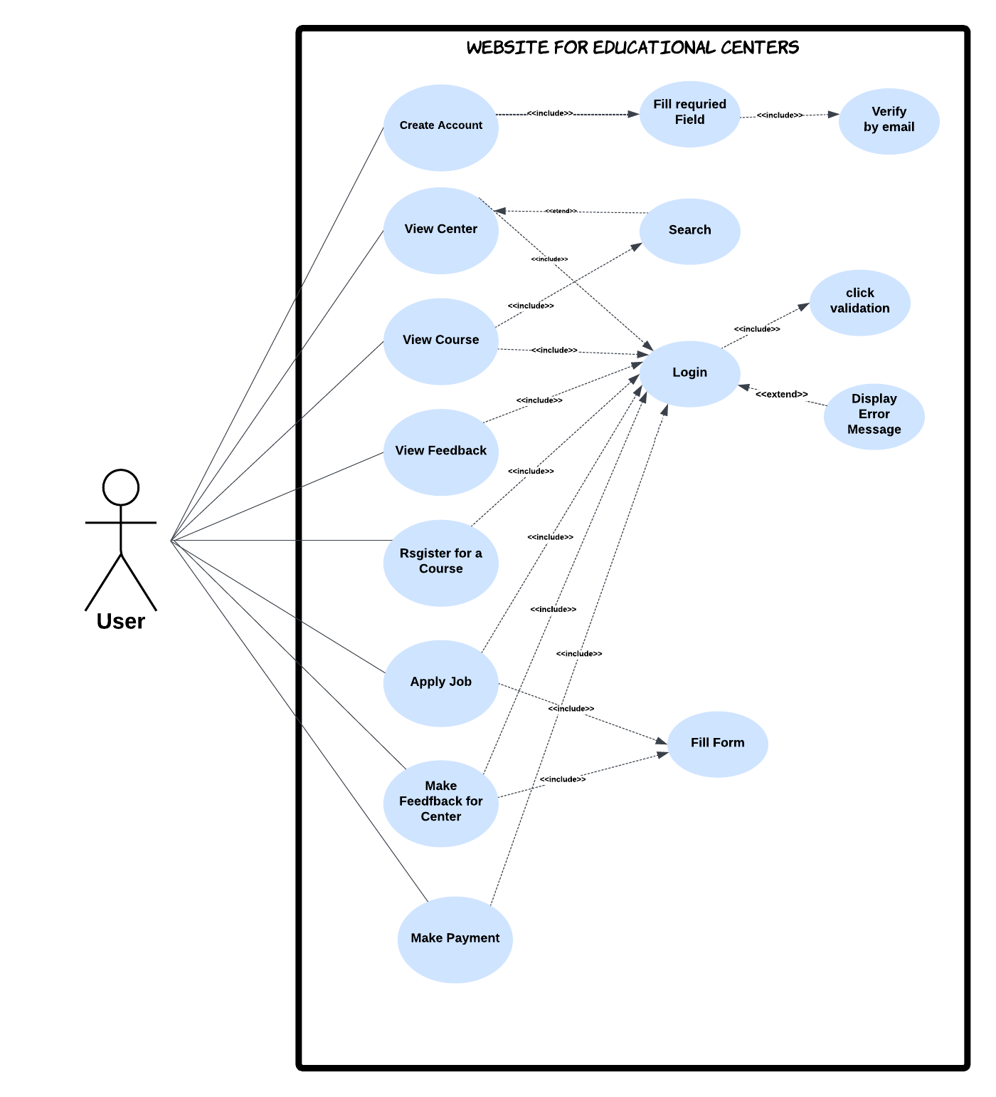**Figure 4-1**

4-1-2 Admin

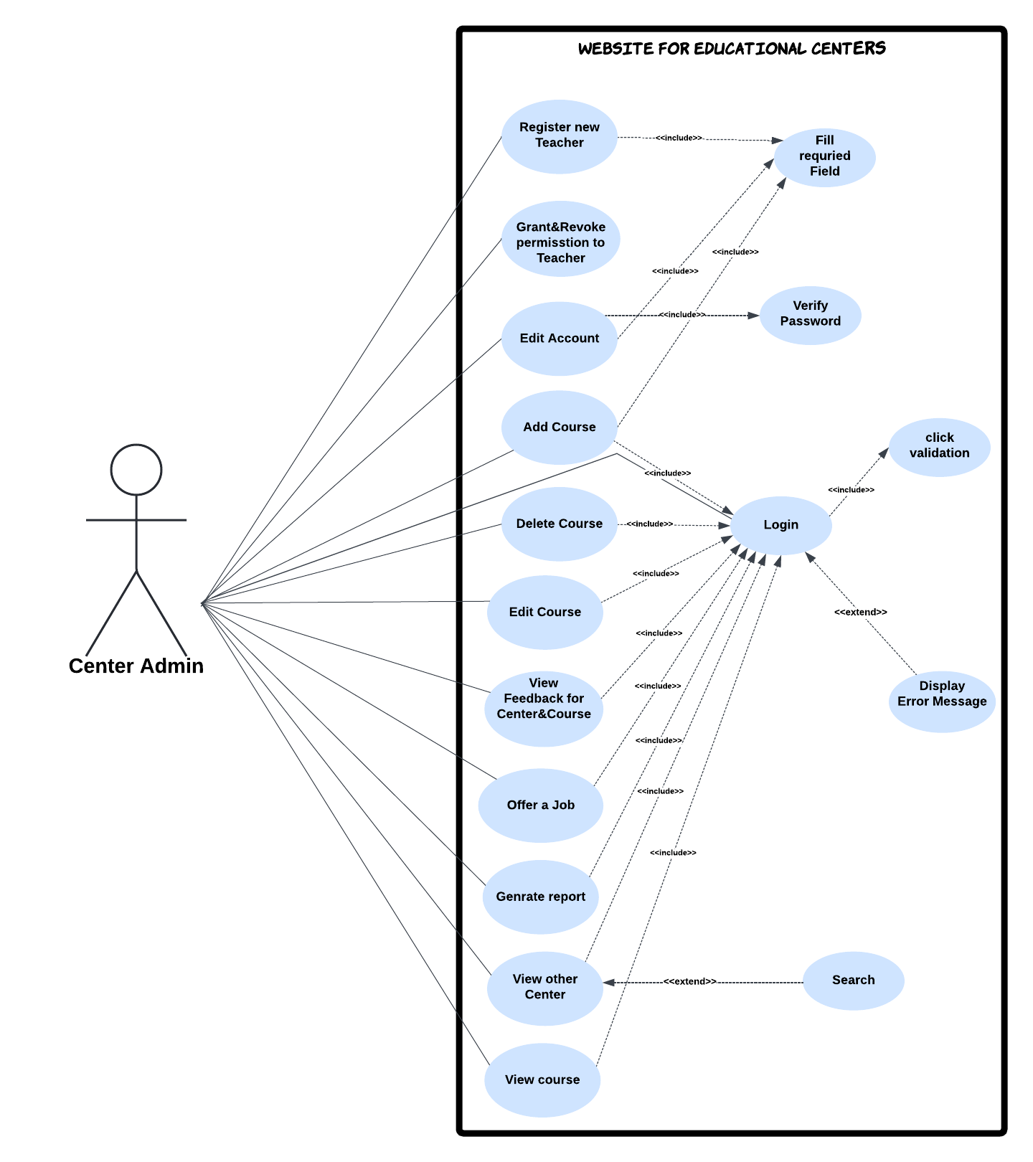

**Figure 4-2**

4-1-3 Teacher

## 

**Figure 4-3**

4-2 Use Case Descriptions

|  |  |
| --- | --- |
| **Use case name: Register new Teacher** | |
| **Actor** | Admin |
| **Type** | Primary |
| **Description** | The Admin intend to create an account for a Teacher so he/she enter Teacher information then the account create |
| **Stimulus** | When Admin click a button(register new teacher) |
| **Response** | The message appear for admin (the account creation process is complete) |
| **Comments** | The Admin is directly responsible for the Teacher ,and since he has created an account for the Teacher he can cancel it. |

|  |  |
| --- | --- |
| **Use case name: offer a job** | |
| **Actor** | Admin |
| **Type** | Primary |
| **Description** | In case a center need a Teacher the admin will announce the center need for a Teacher so Admin fill the descriptive form. |
| **Stimulus** | When Admin click a button(Announcing our need for a teacher) |
| **Response** | The message appear for admin (the process is complete) |
| **Comments** | A notification will be sent to all user |

|  |  |
| --- | --- |
| **Use case name: Make a Feedback** | |
| **Actor** | User |
| **Type** | Primary |
| **Description** | The user make a feedback after fill a form . |
| **Stimulus** | When user click a button(send feedback) |
| **Response** | The message appear 'The feedback is submitted' |
| **Comments** | The user must register at least one course to make a feedback |

|  |  |
| --- | --- |
| **Use case name: Create an account** | |
| **Actor** | user |
| **Type** | Primary |
| **Description** | The user can create account after fill some required field or by using Gmail then the user is a part of our website. |
| **Stimulus** | When user click a sign up button |
| **Response** | The message appear for user 'The account created' |
| **comments** | After create account the user can access to all service(see center, course ,location …etc) |

4-3 Sequence Diagrams:

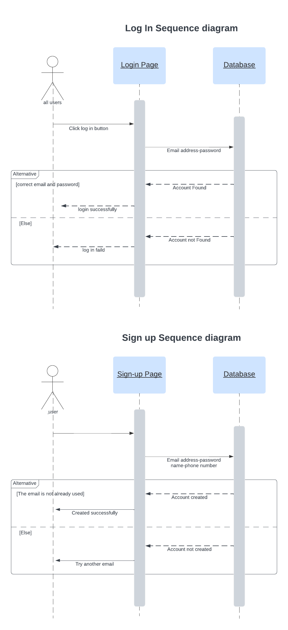

**Figure 4-4**

**Figure 4-5**

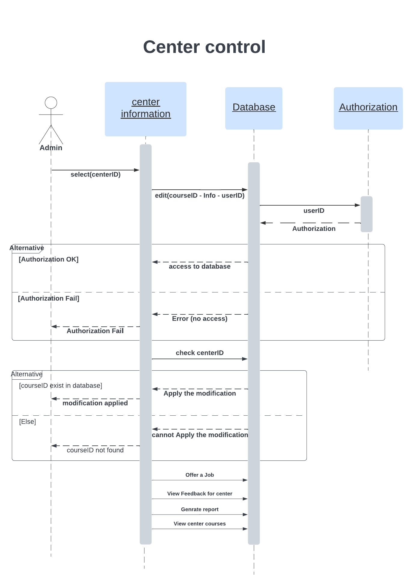

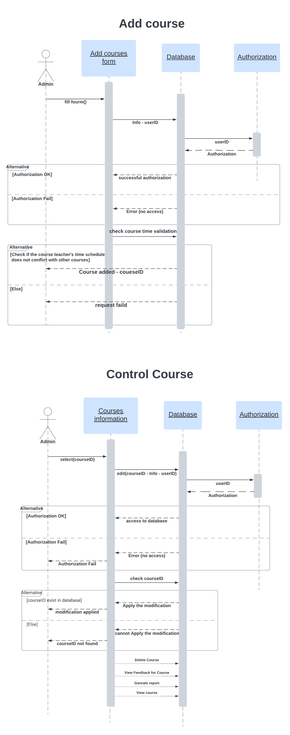**Figure 4-6**

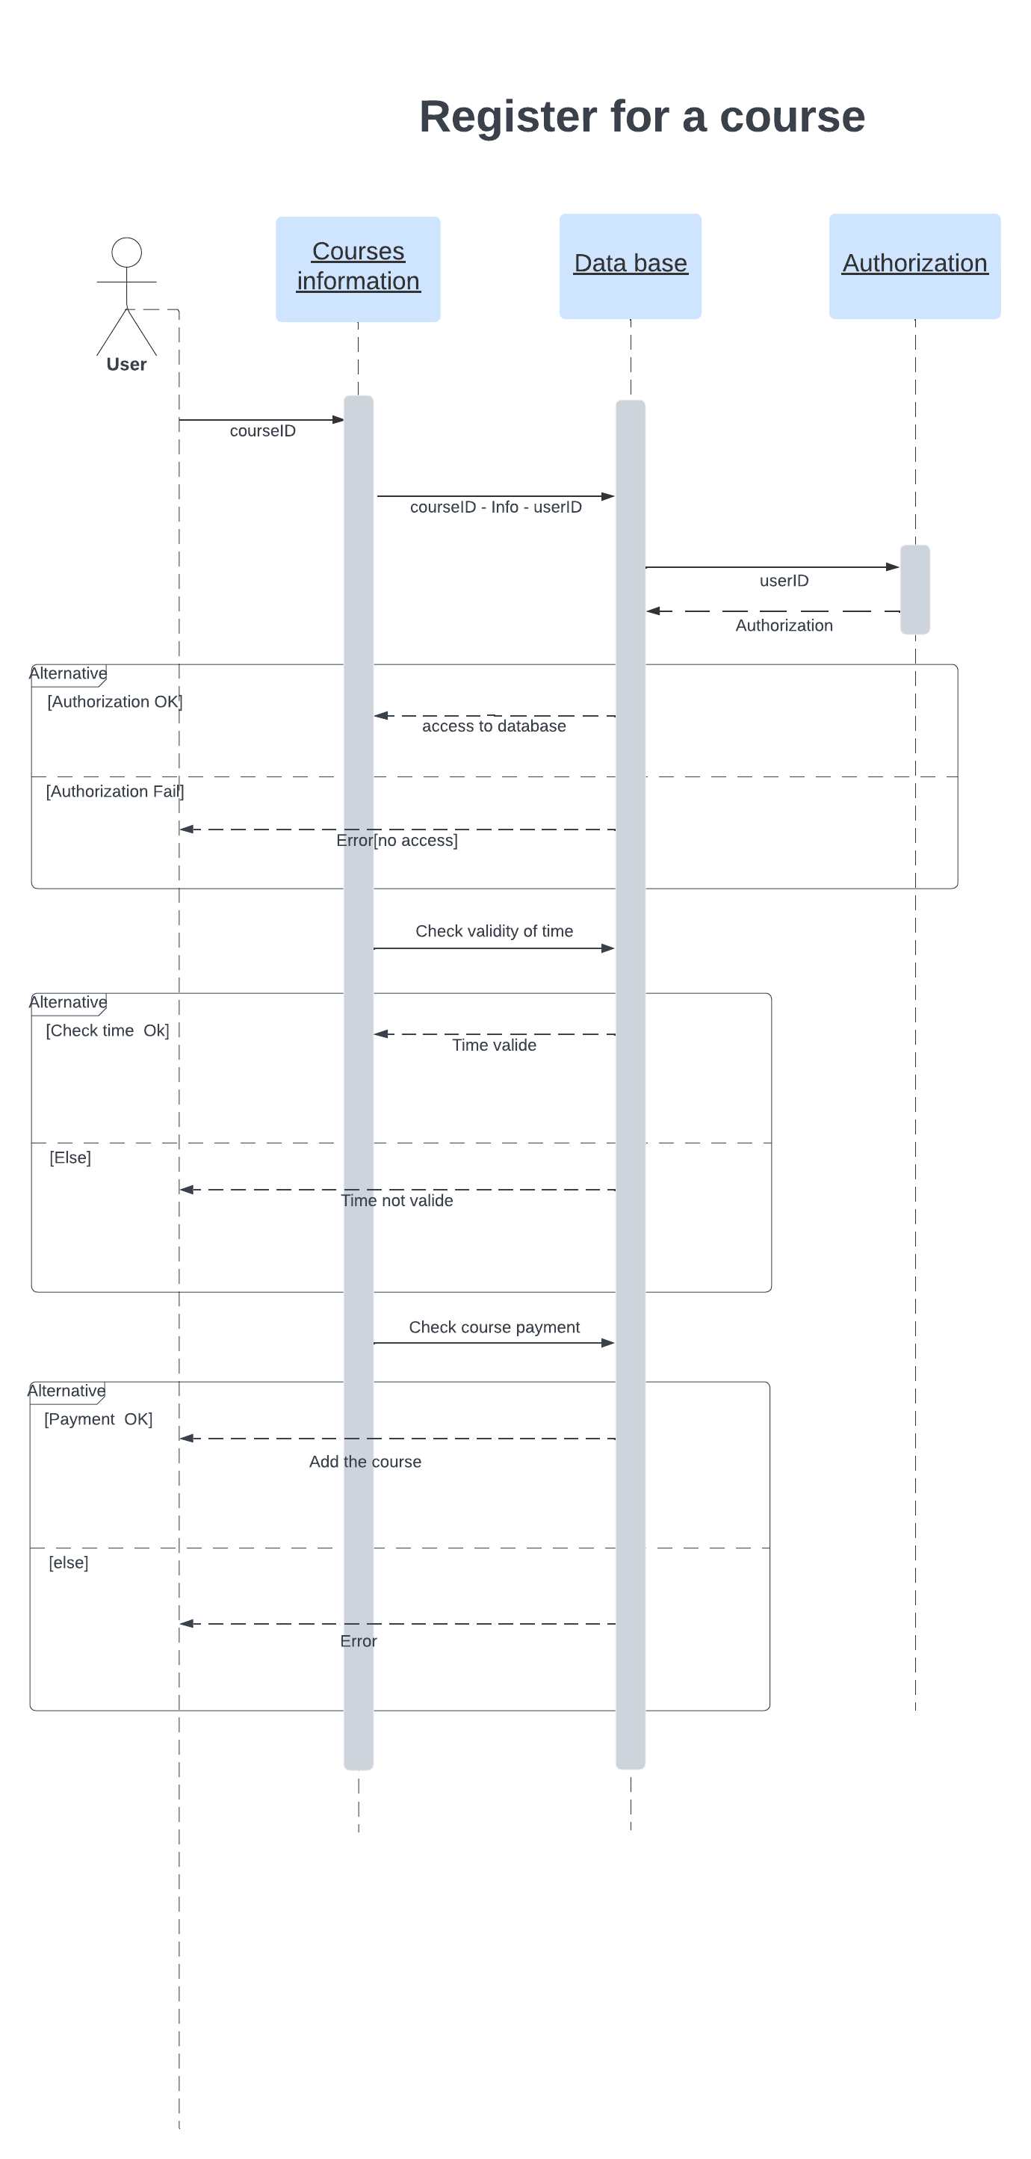Figure 4-7

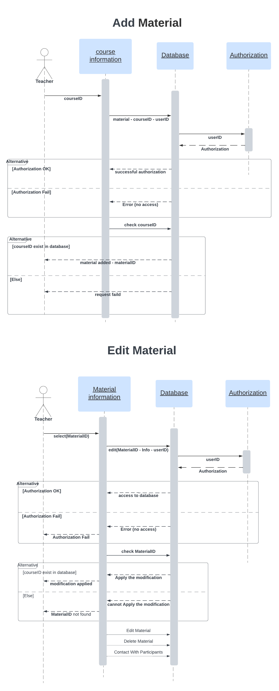

**Figure 4-8**

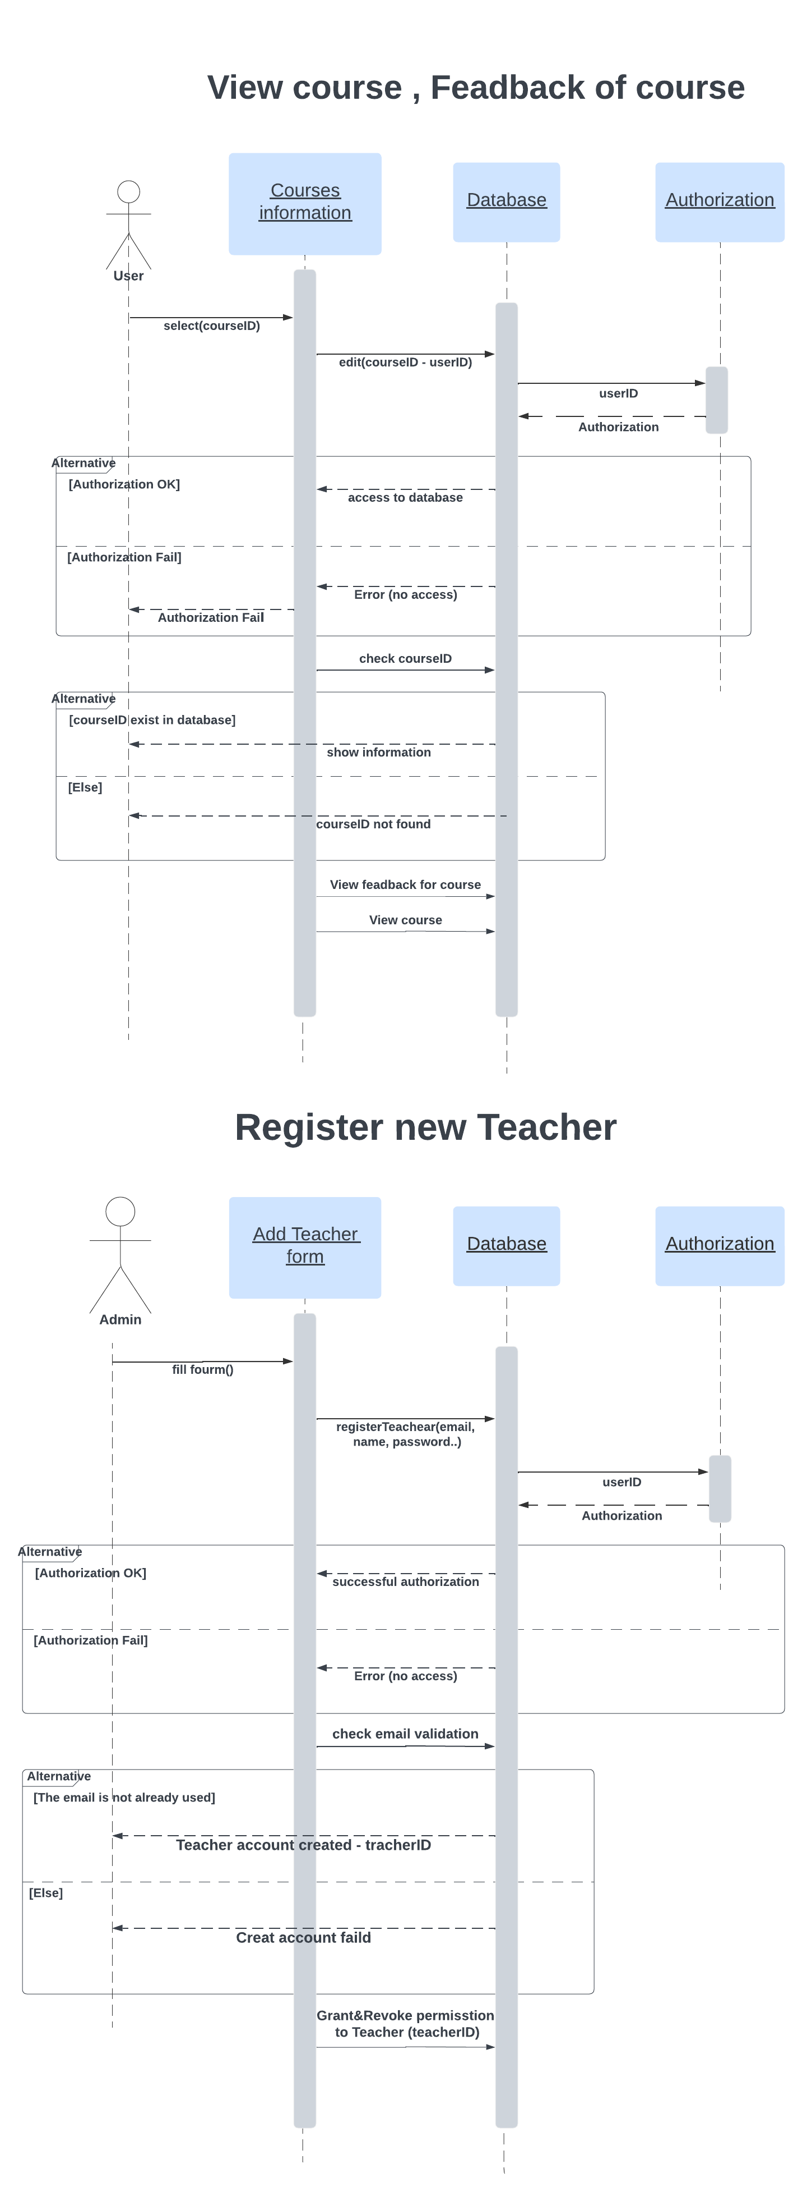

Figure 4-9

4-4 Activity Diagrams:

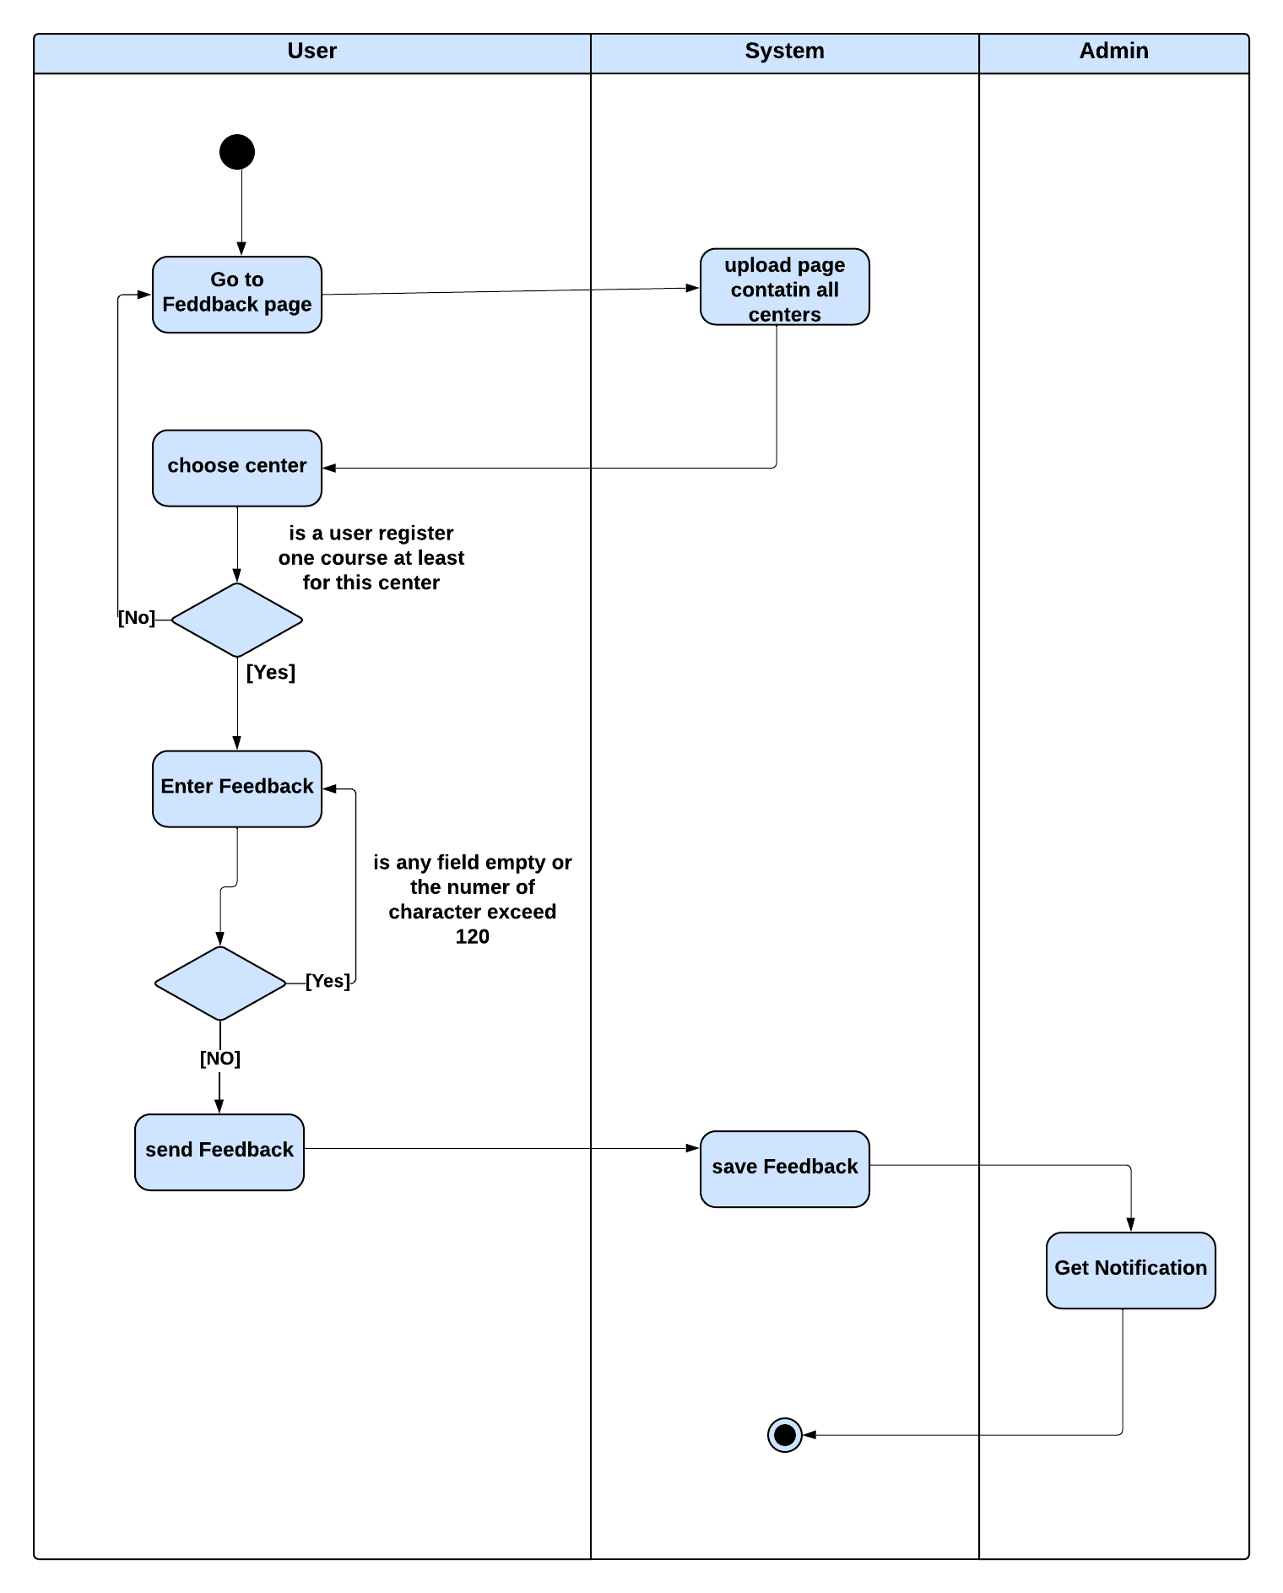

Figure 4-10

Figure 4-11

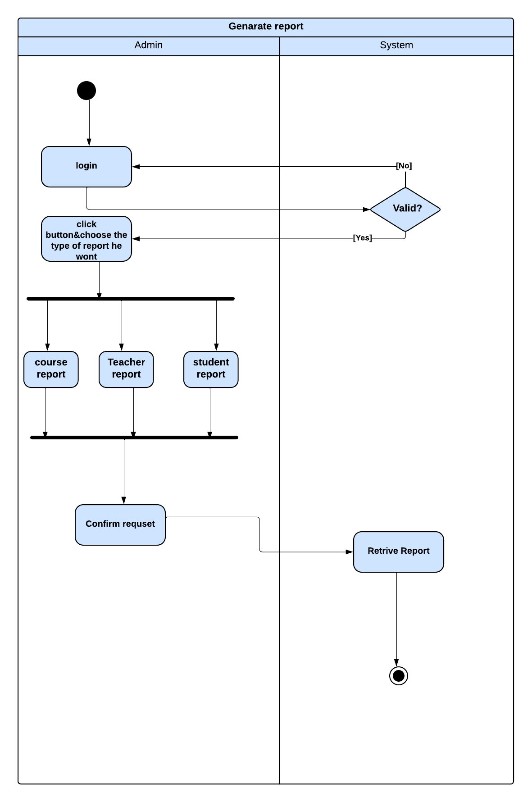

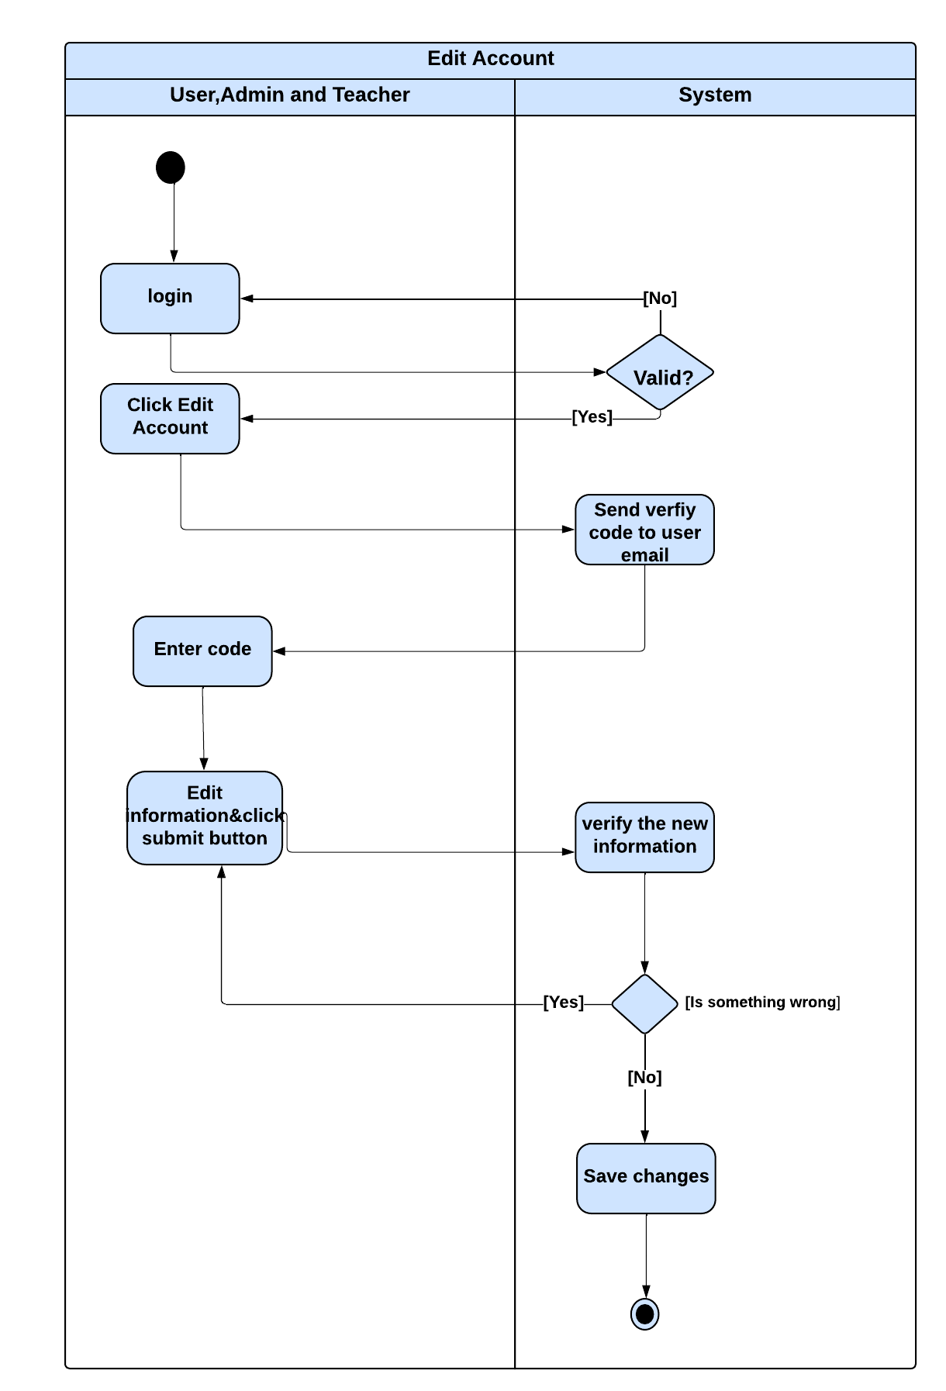

Figure 4-12

4-5 Class Diagram :

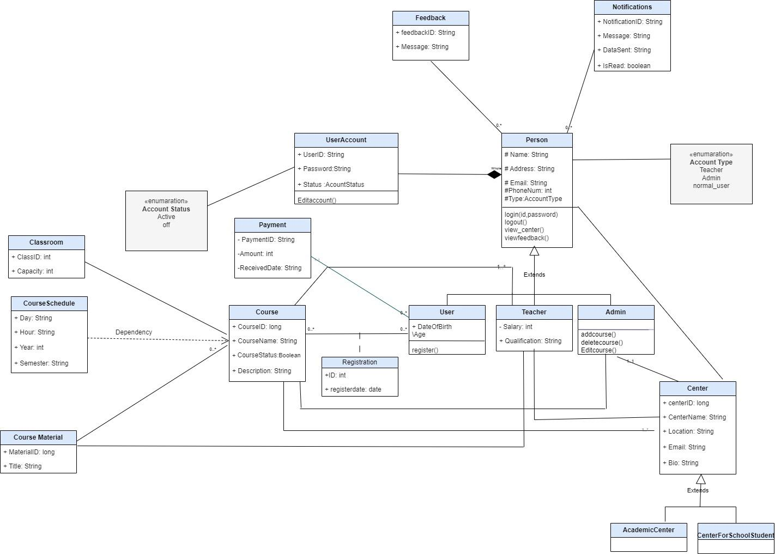

Figure 4-13

## Chapter 5: Interface Design

5-1 Home Page Design:

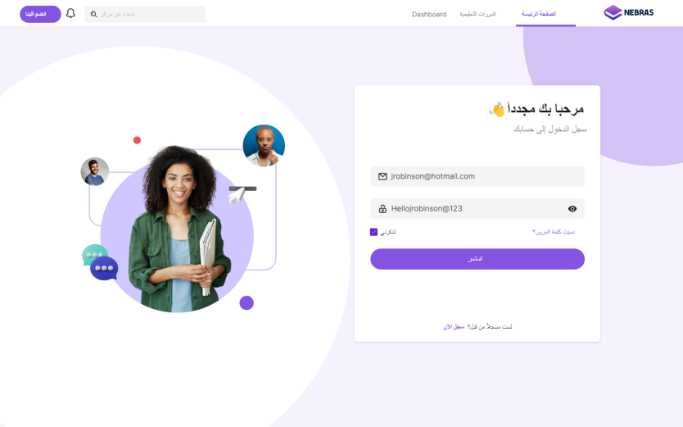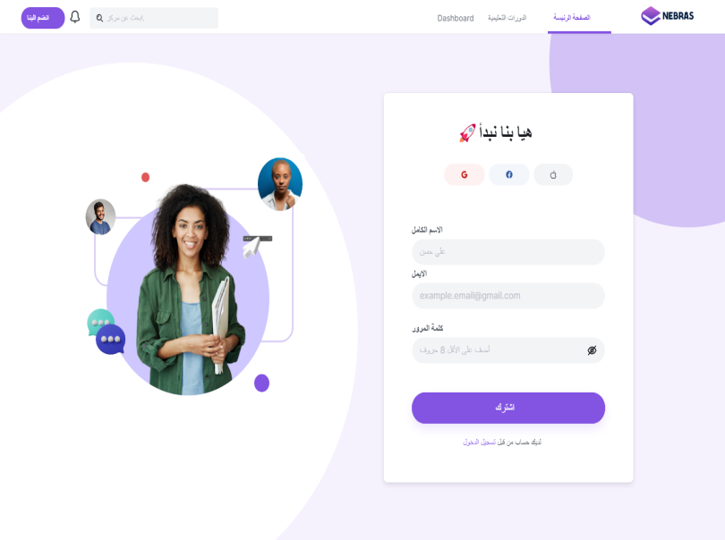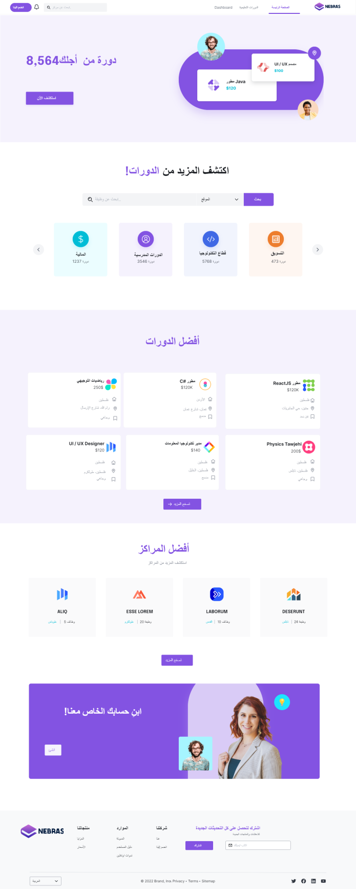

**5-2 User Interface:**

**Home Page**

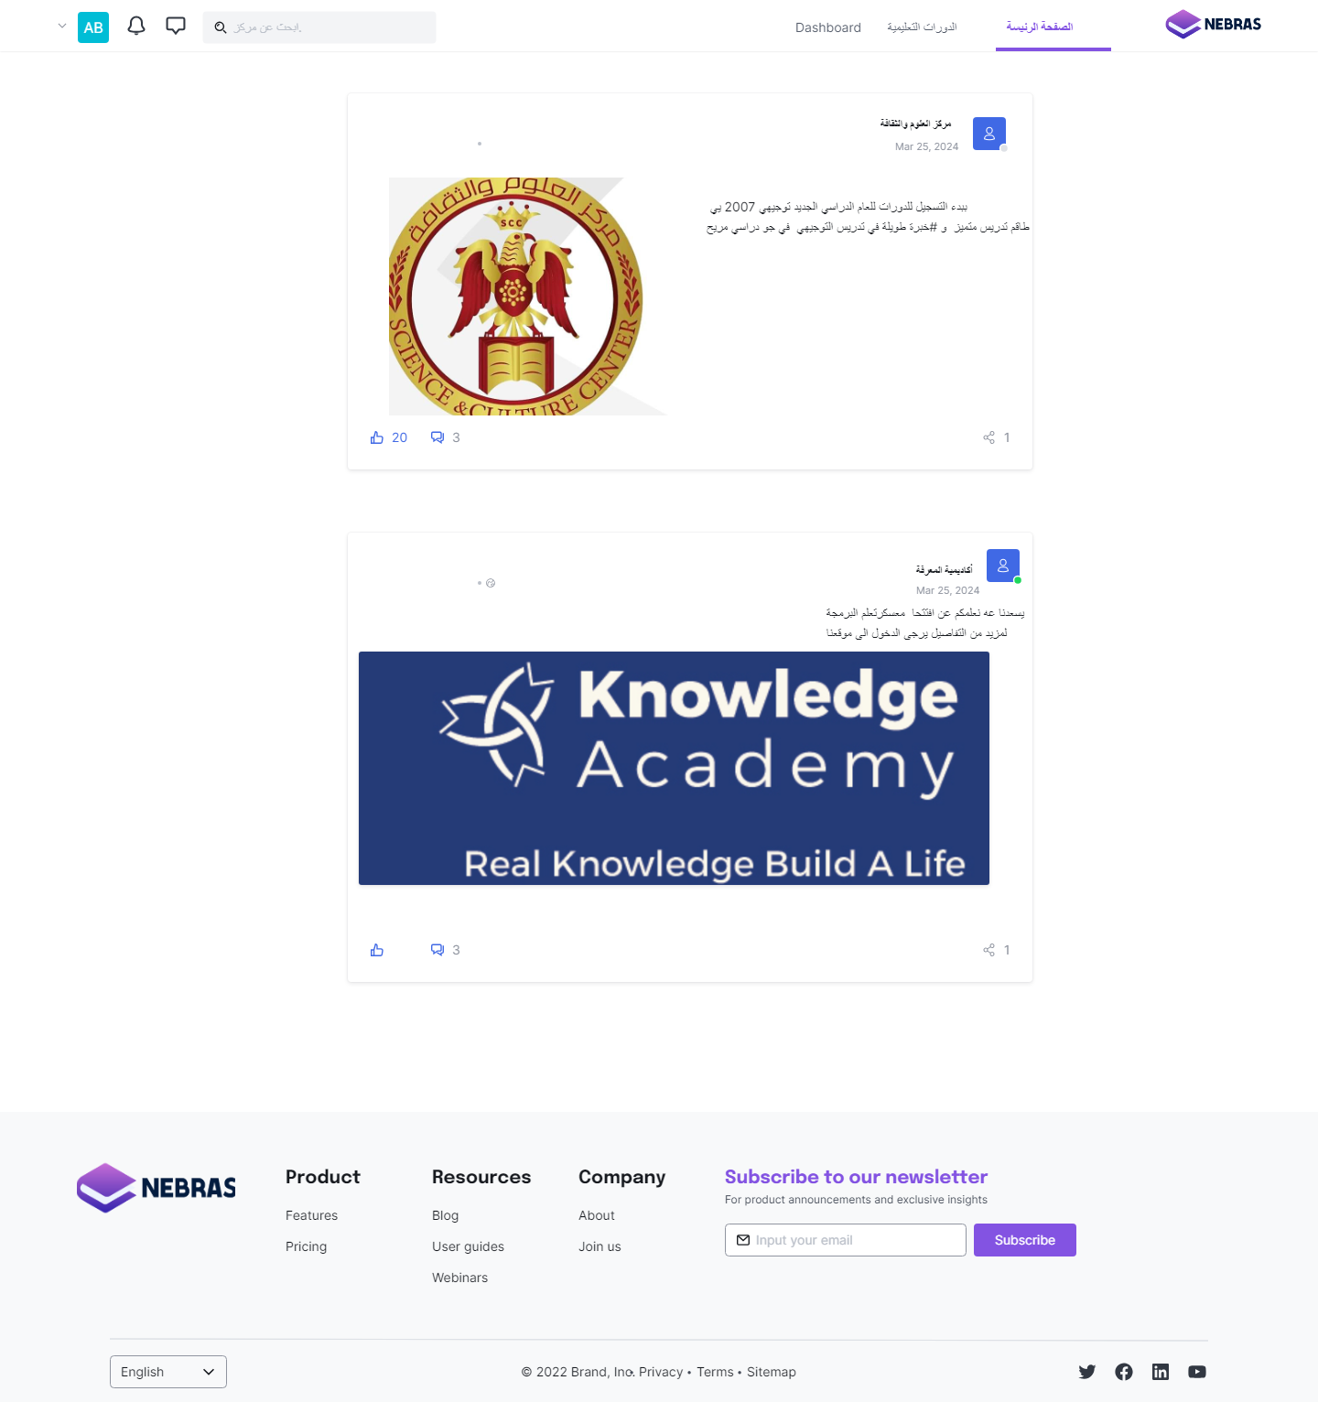

**Account Settings**

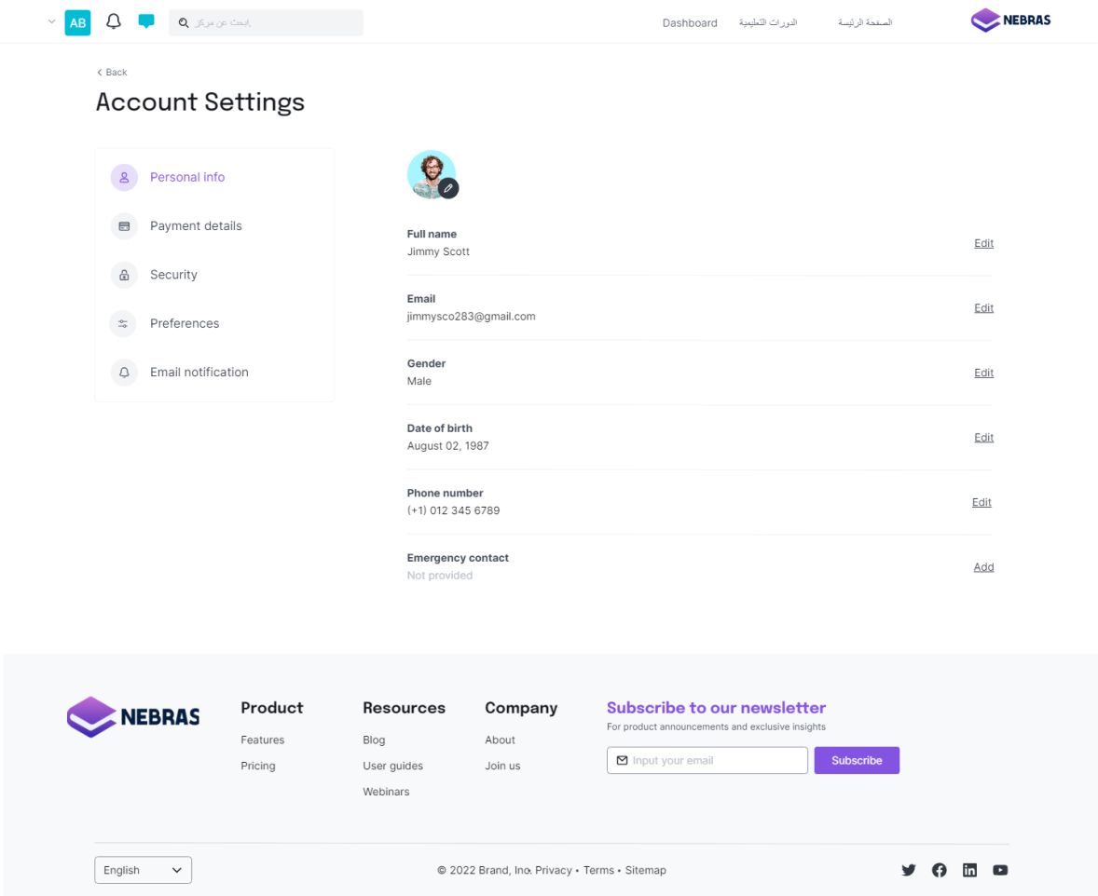

**Chat- inbox**

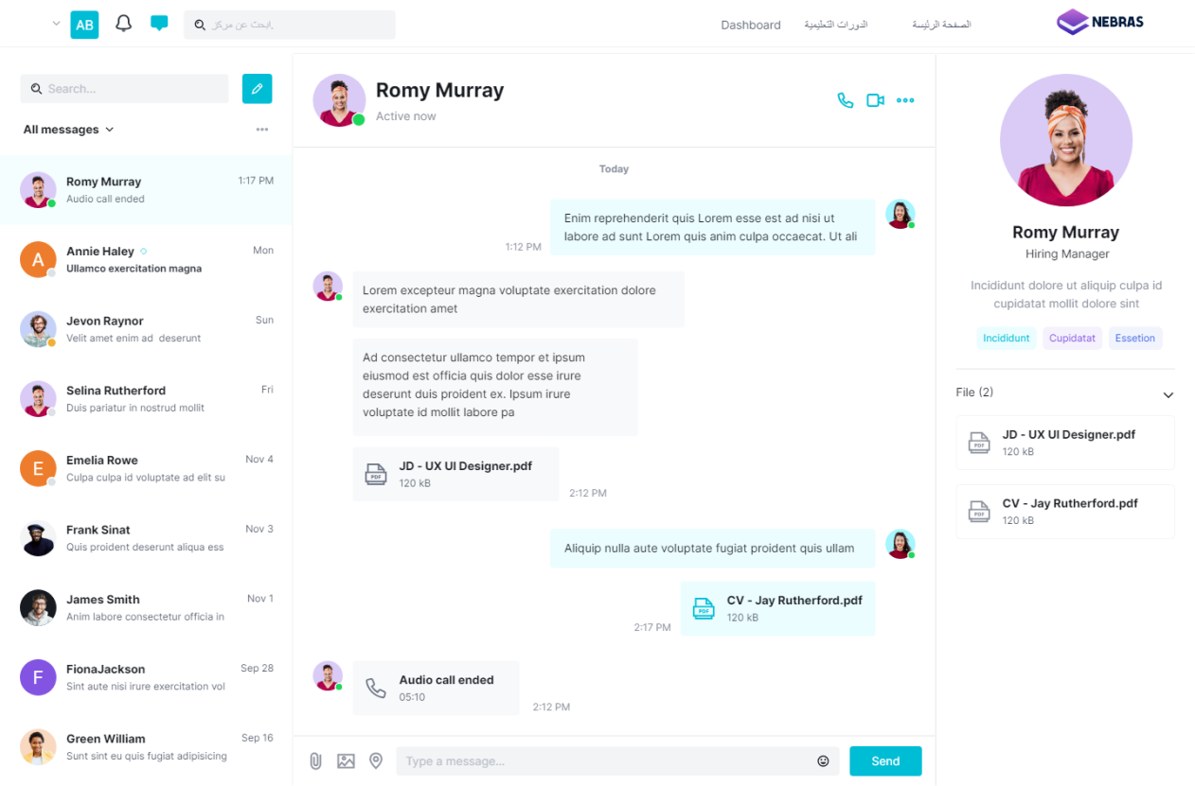

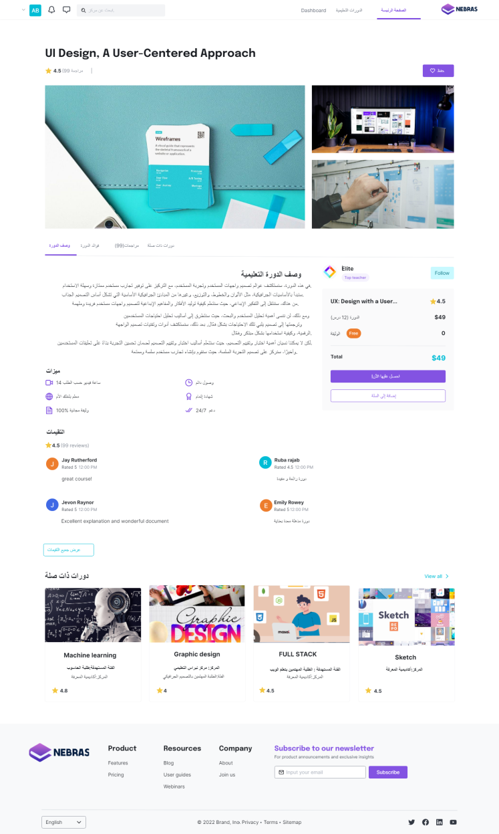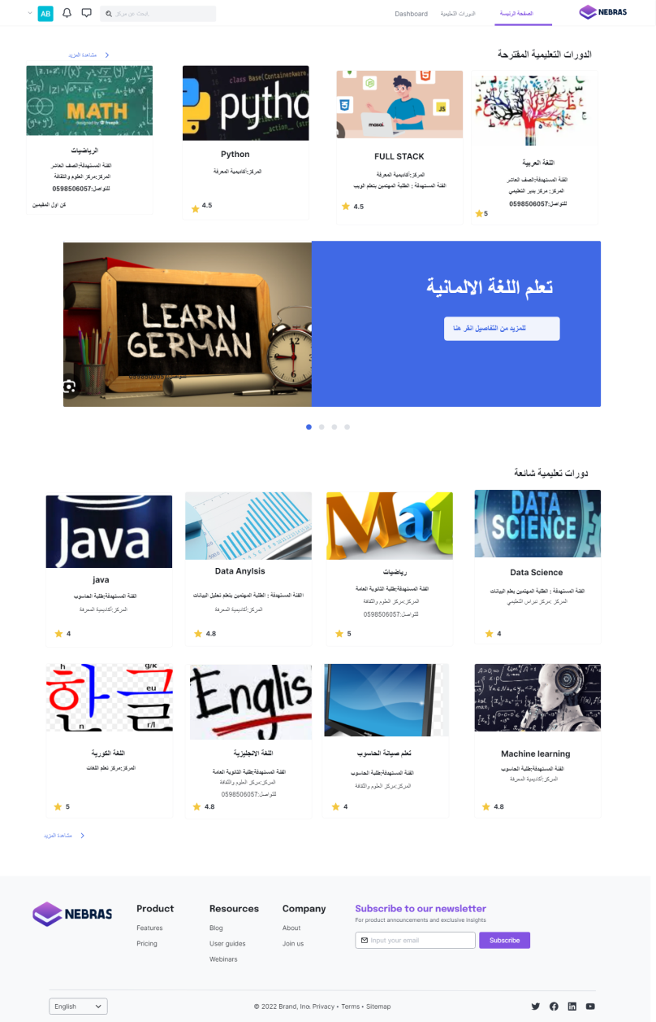

**Course Listing Course Details**

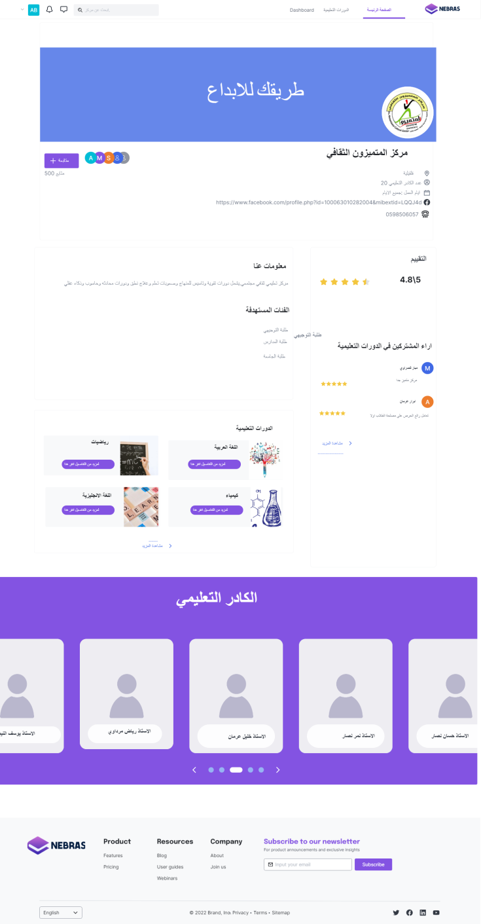

**Center Profile Learning-Study& Discuss**

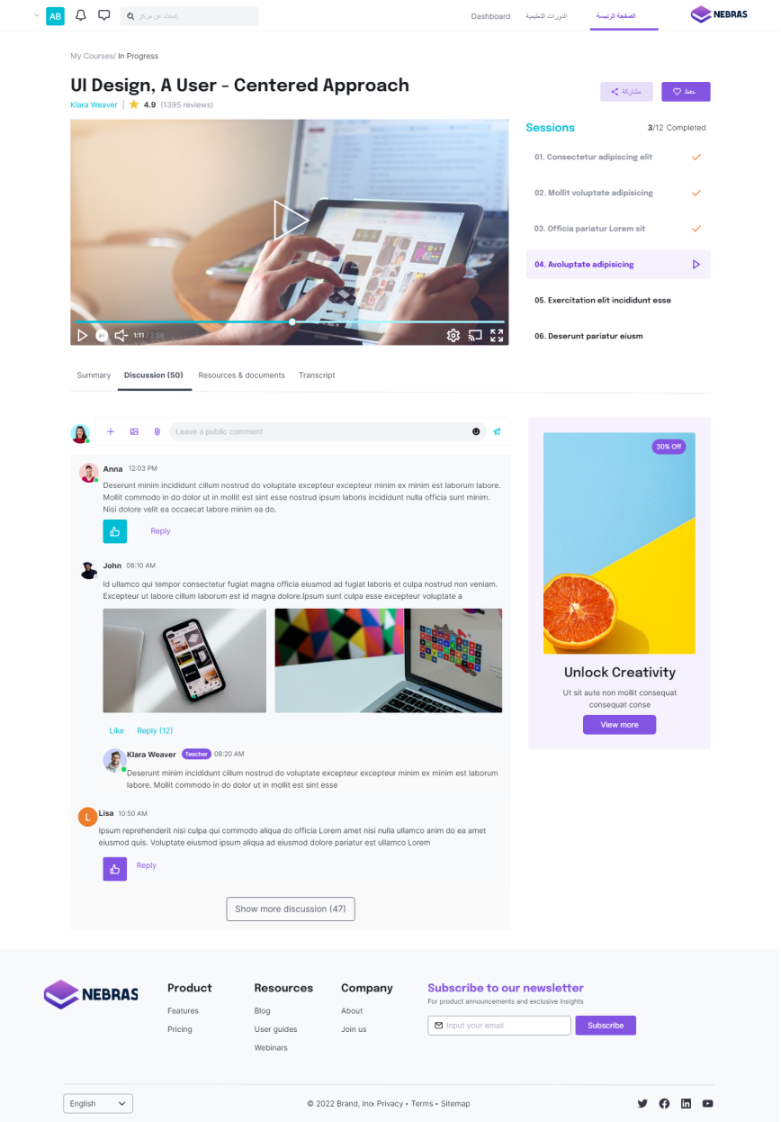

**Calendar**

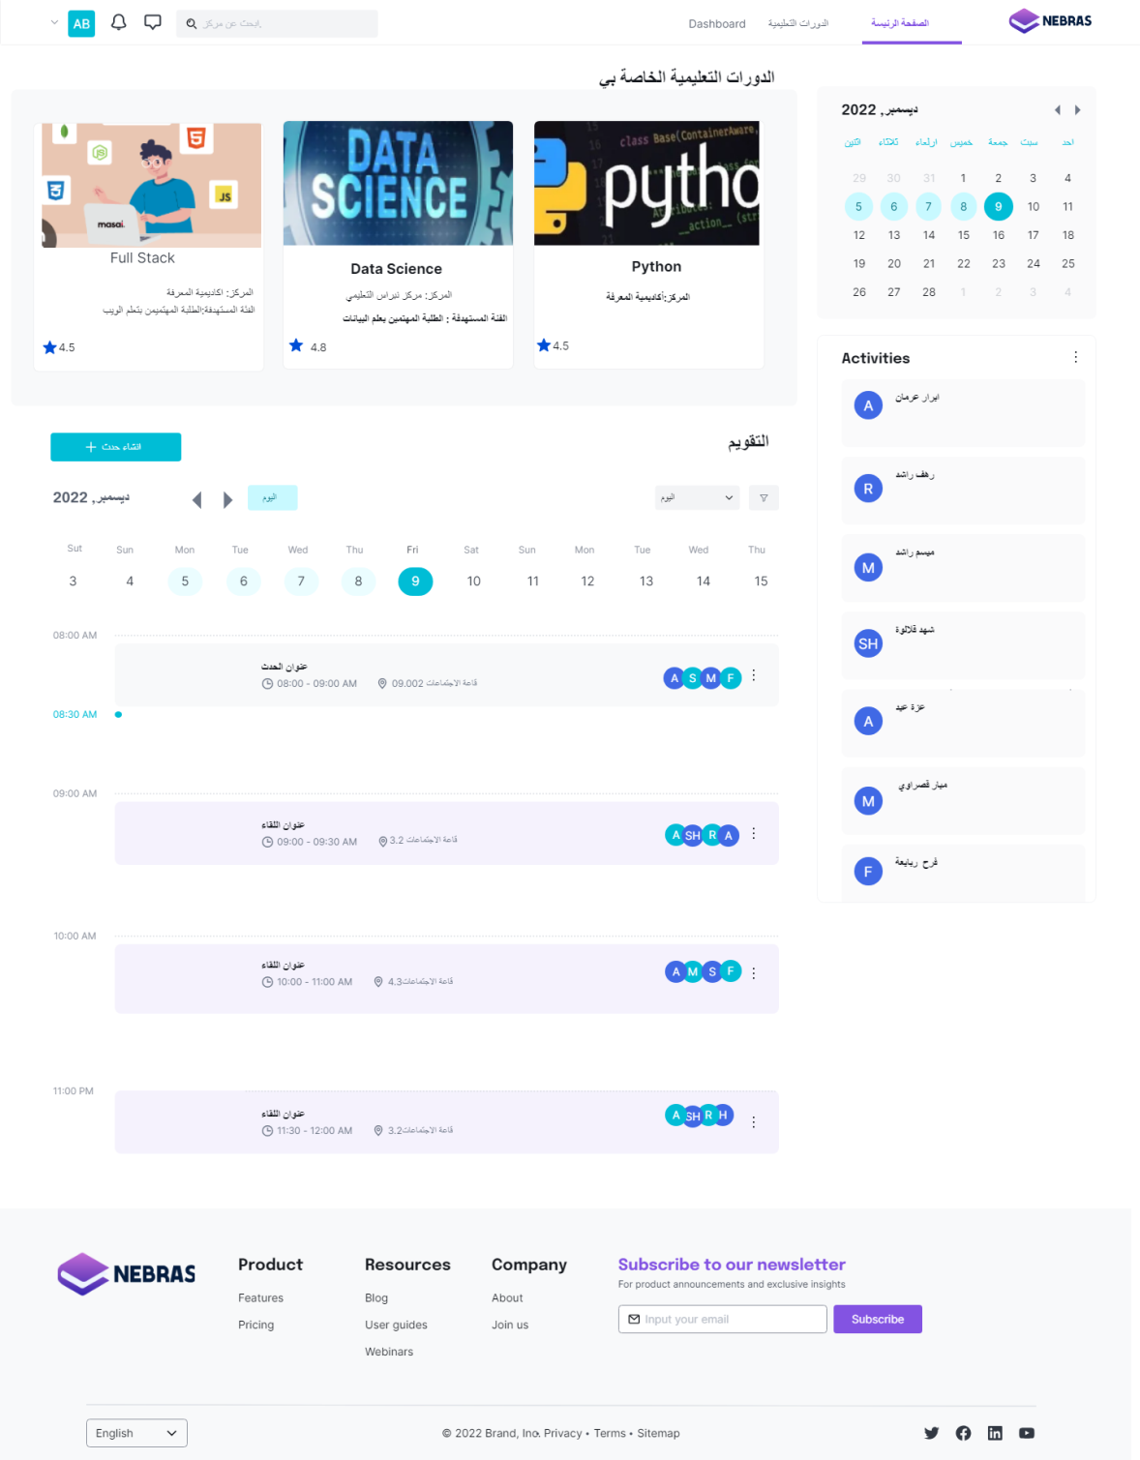

**5-3 Admin Interface:**

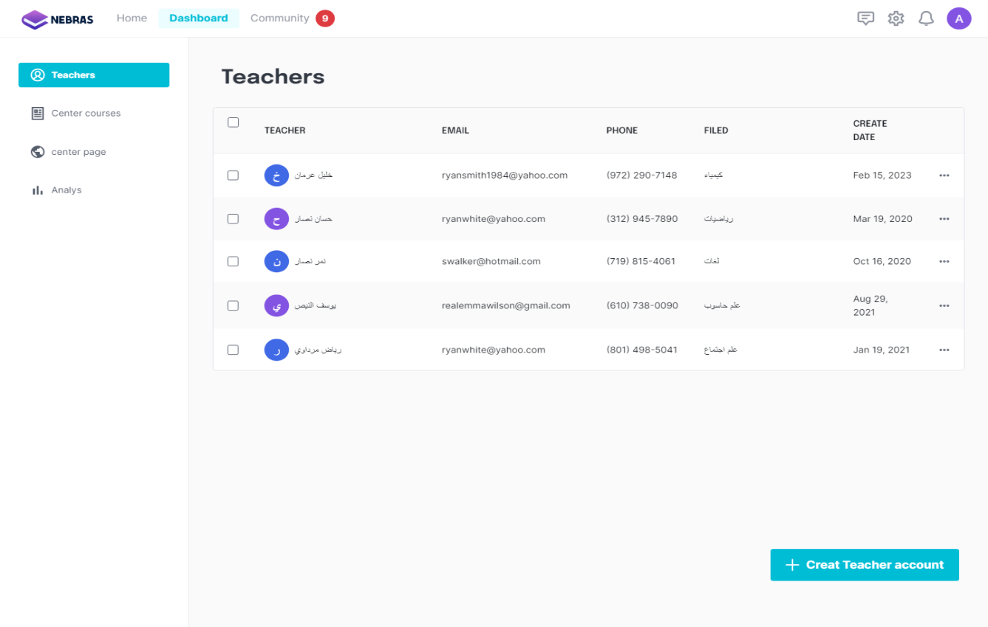

**Teachers Management**

**Add New Course**

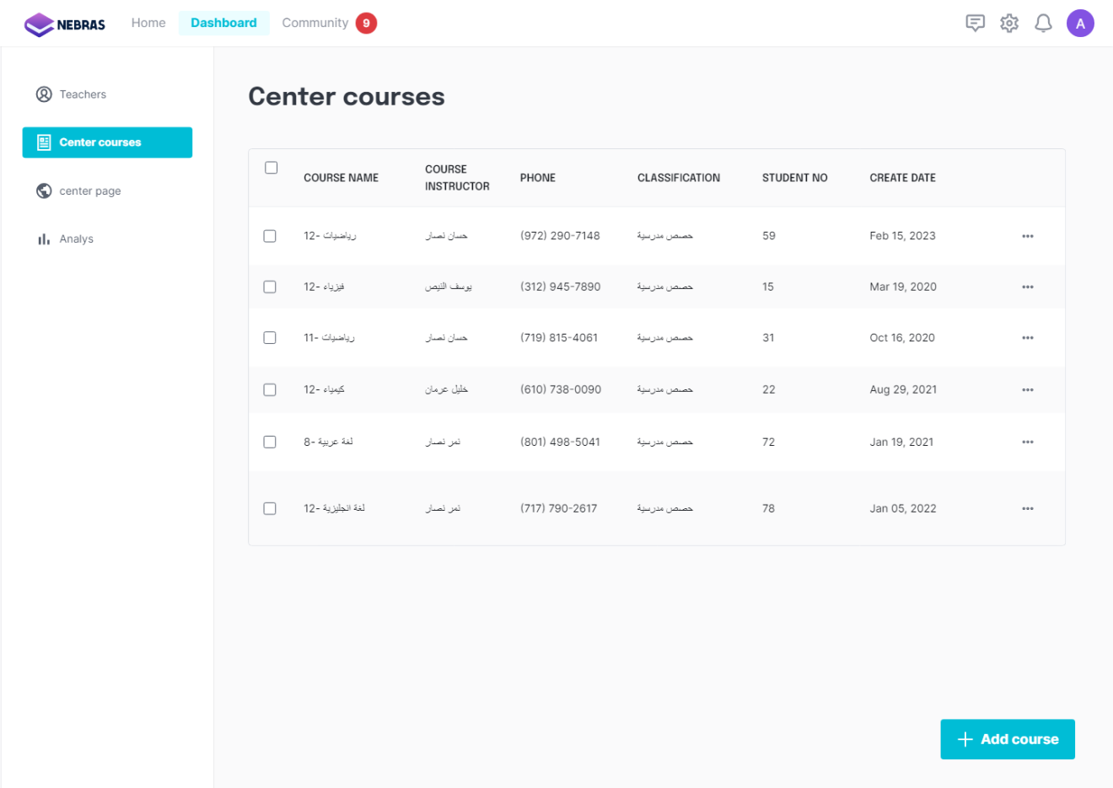

**Dashboard**

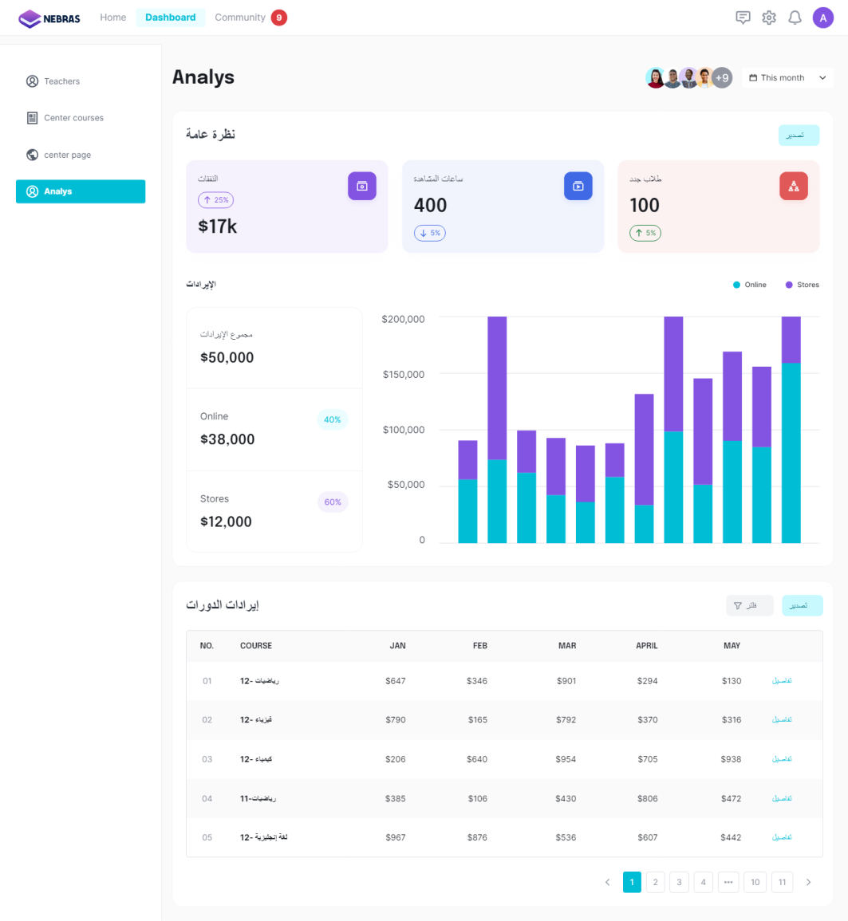

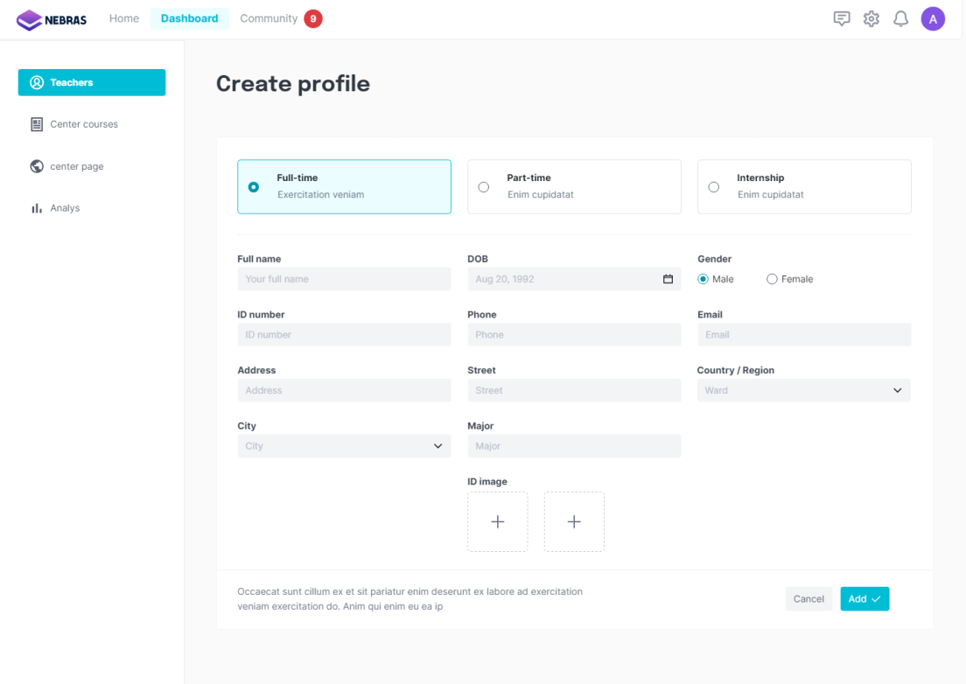**Add Teacher**

**Create Course**

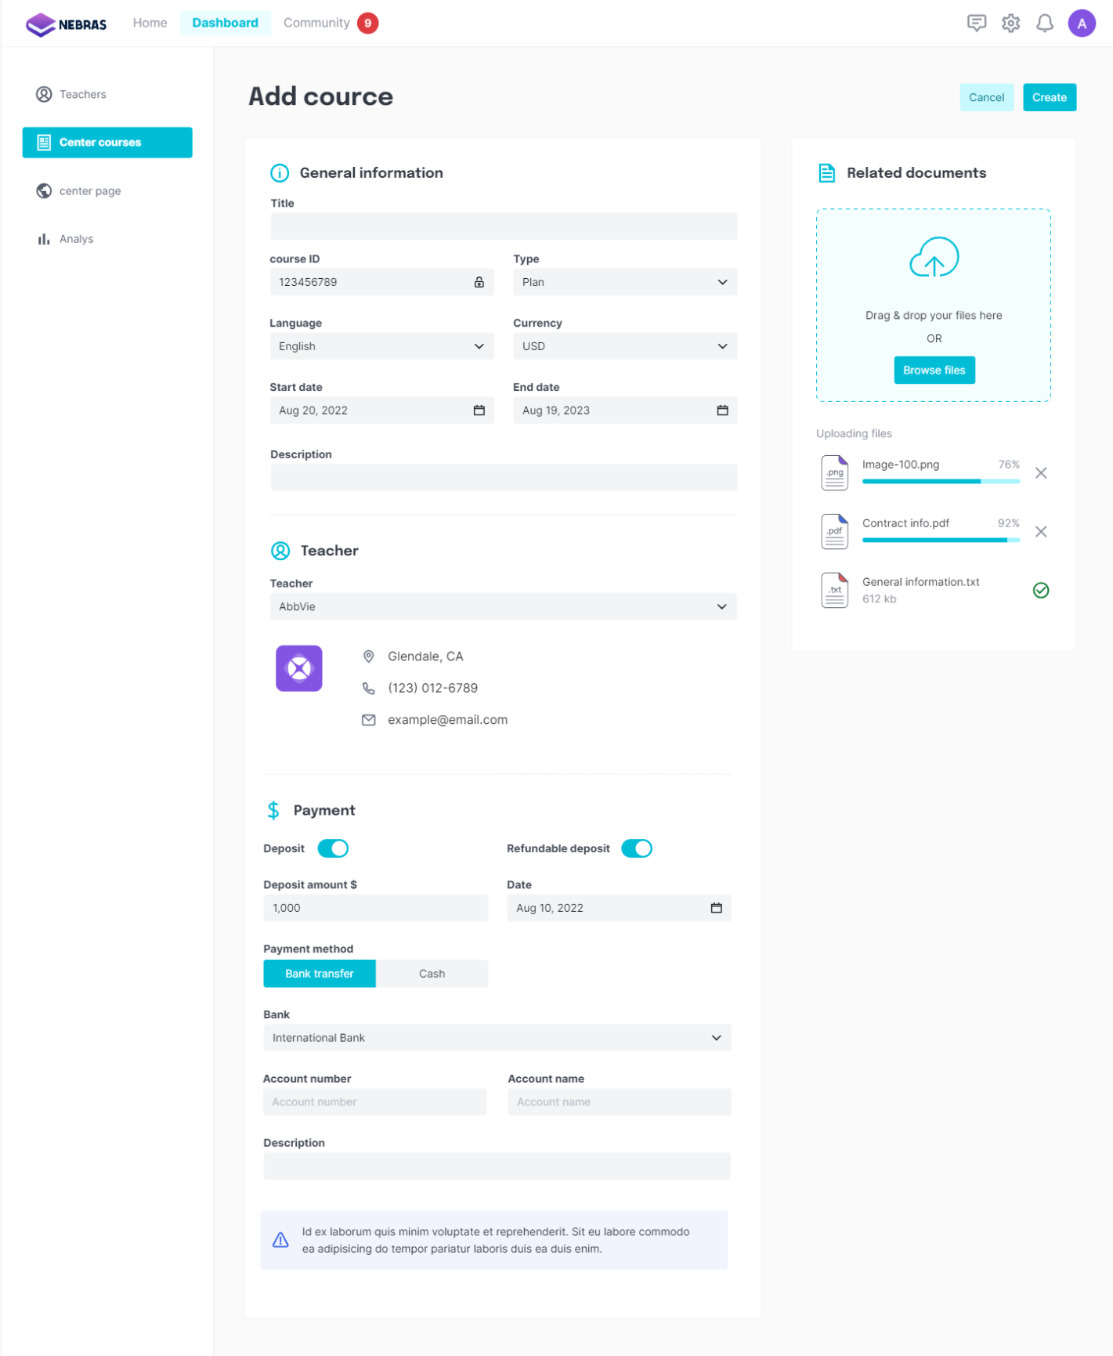

**5-4 Teacher Interface:**

**Create Course**

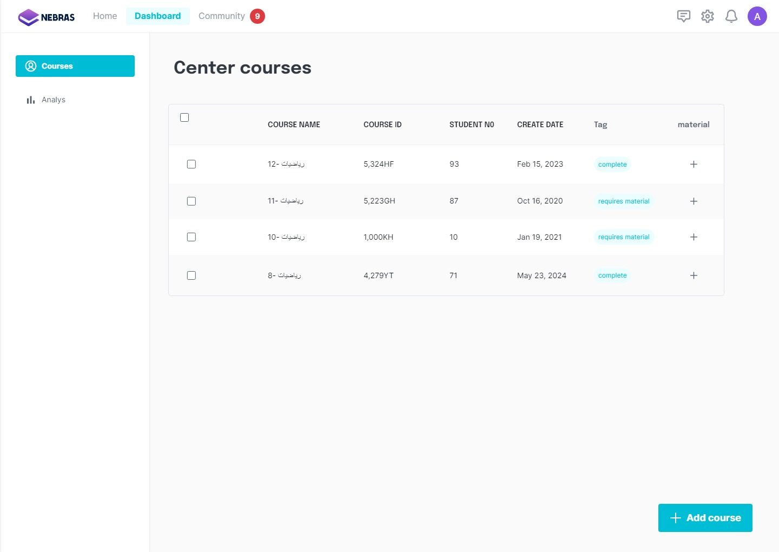

**Upload Files**

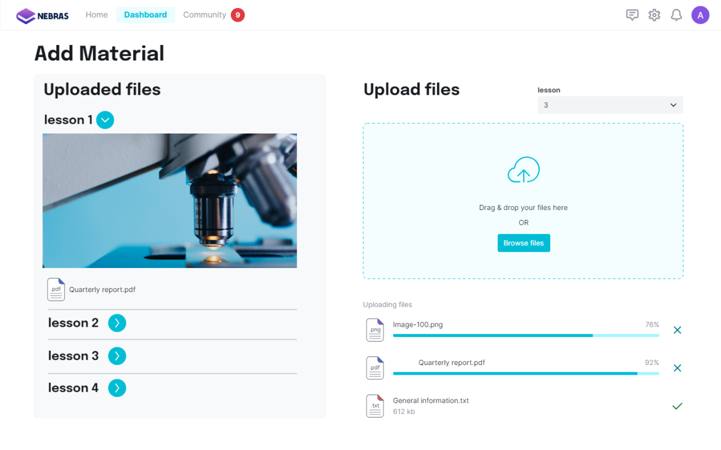

**Community**

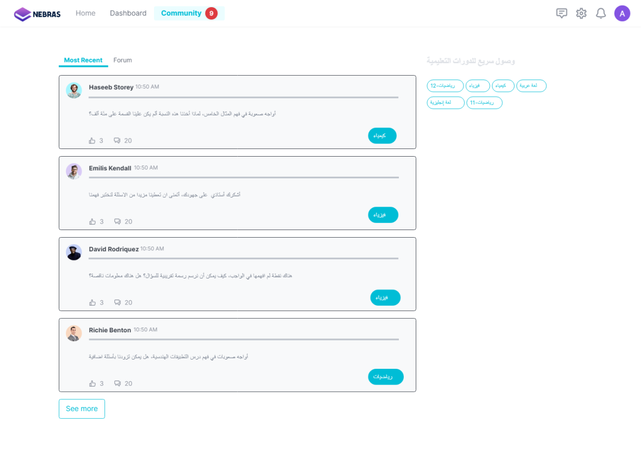

**Dashboard**

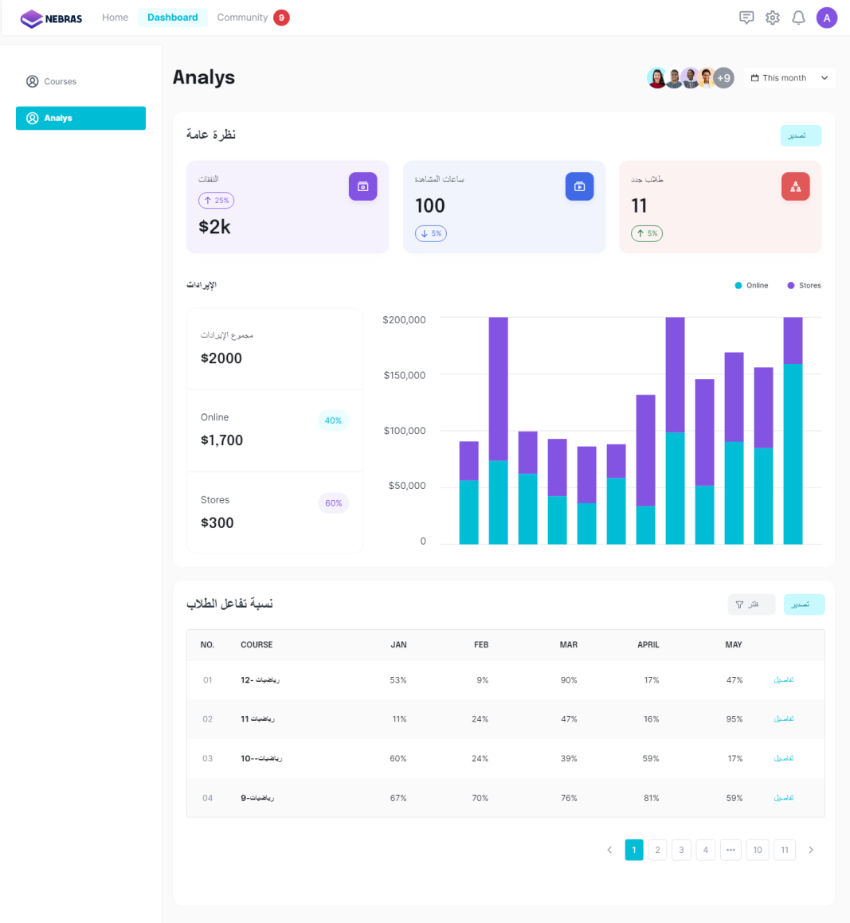

**References**

1. Visual Paradigm. What is Use Case Diagram? [Website]. Retrieved from https://www.visual-paradigm.com/guide/uml-unified-modeling-language/what-is-use-case-diagram/
2. Visual Paradigm. What is Sequence Diagram? [Website]. Retrieved from https://www.visual-paradigm.com/guide/uml-unified-modeling-language/what-is-sequence-diagram/
3. Visual Paradigm. What is Class Diagram? [Website]. Retrieved from https://www.visual-paradigm.com/guide/uml-unified-modeling-language/what-is-class-diagram/
4. IBM. (2021, Jul 17). Enumerations in UML classifiers. [Website]. Retrieved from https://www.ibm.com/docs/en/dma?topic=diagrams-enumerations
5. Visual Paradigm. What is Activity Diagram? [Website]. Retrieved from https://www.visual-paradigm.com/guide/uml-unified-modeling-language/what-is-activity-diagram/
6. Visual Paradigm. All You Need to Know about State Diagrams. [Website]. Retrieved from https://www.visual-paradigm.com/guide/uml-unified-modeling-language/about-state-diagrams/
7. Folcrum. (2022, Apr 23).How to Create SRS for Edtech App: Don’t Reinvent the Wheel, Take What’s Already Written [Website] Retrieved from https://fulcrum.rocks/blog/how-to-create-srs-for-edtech-app.
8. Creately. Create account use case diagram [Website] Retrieved from https://creately.com/diagram/example/g8rv36193/create-account-use-case-diagram
9. Creately. (2022, Oct 20).Class Diagram Templates to Instantly Create Class Diagrams [Website] Retrieved from https://creately.com/blog/examples/class-diagram-templates/
10. Splunk. Data & Database Normalization Explained: How To [Website] Retrieved from https://www.splunk.com/en_us/blog/learn/data-normalization.html
11. Artoftesting. ER Diagram | What is Entity Relationship Diagram or ERD? [Website] Retrieved from https://artoftesting.com/er-diagram-erd-entity-relationship-diagram
12. Geeksforgeeks. ( 22 Mar, 2024). Generalization, Specialization and Aggregation in ER Model [Website] Retrieved from https://www.geeksforgeeks.org/generalization-specialization-and-aggregation-in-er-model/

**Appendix**:

<https://github.com/shahdqalalweh/Software-Engineering>